# Microsoft Intune Device Management Project

## Project Overview

This project demonstrates the deployment and management of Windows devices using Microsoft Intune and Microsoft Entra ID.  
The objective was to configure a modern endpoint management workflow including user creation, automated device enrollment, policy enforcement, and application deployment.

A Windows 10 virtual machine hosted on VMware vSphere was used to simulate a corporate-managed endpoint.

## Technologies Used

* Microsoft Entra ID (Azure AD)
* Microsoft Intune
* Windows Autopilot
* VMware vSphere
* Windows 10
* Microsoft Store (Intune-integrated apps)

## Identity and User Management

Cloud users were created in Microsoft Entra ID to enable authentication and Intune device enrollment. Entra ID acts as the central identity provider for users and devices in this environment.

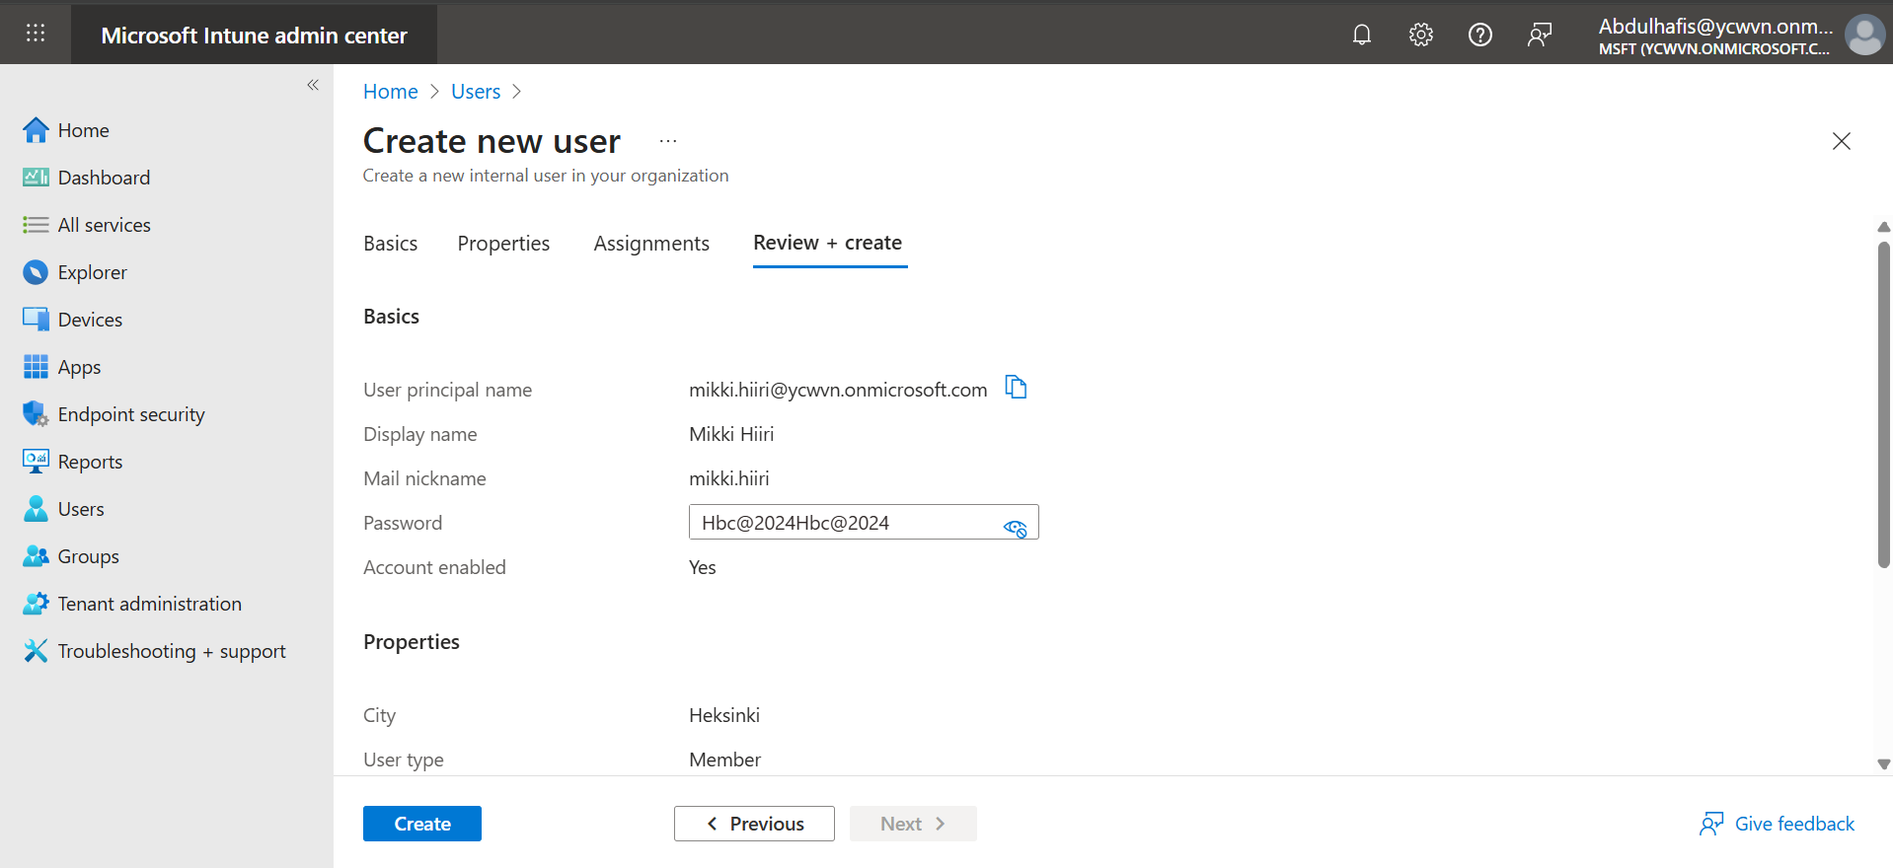

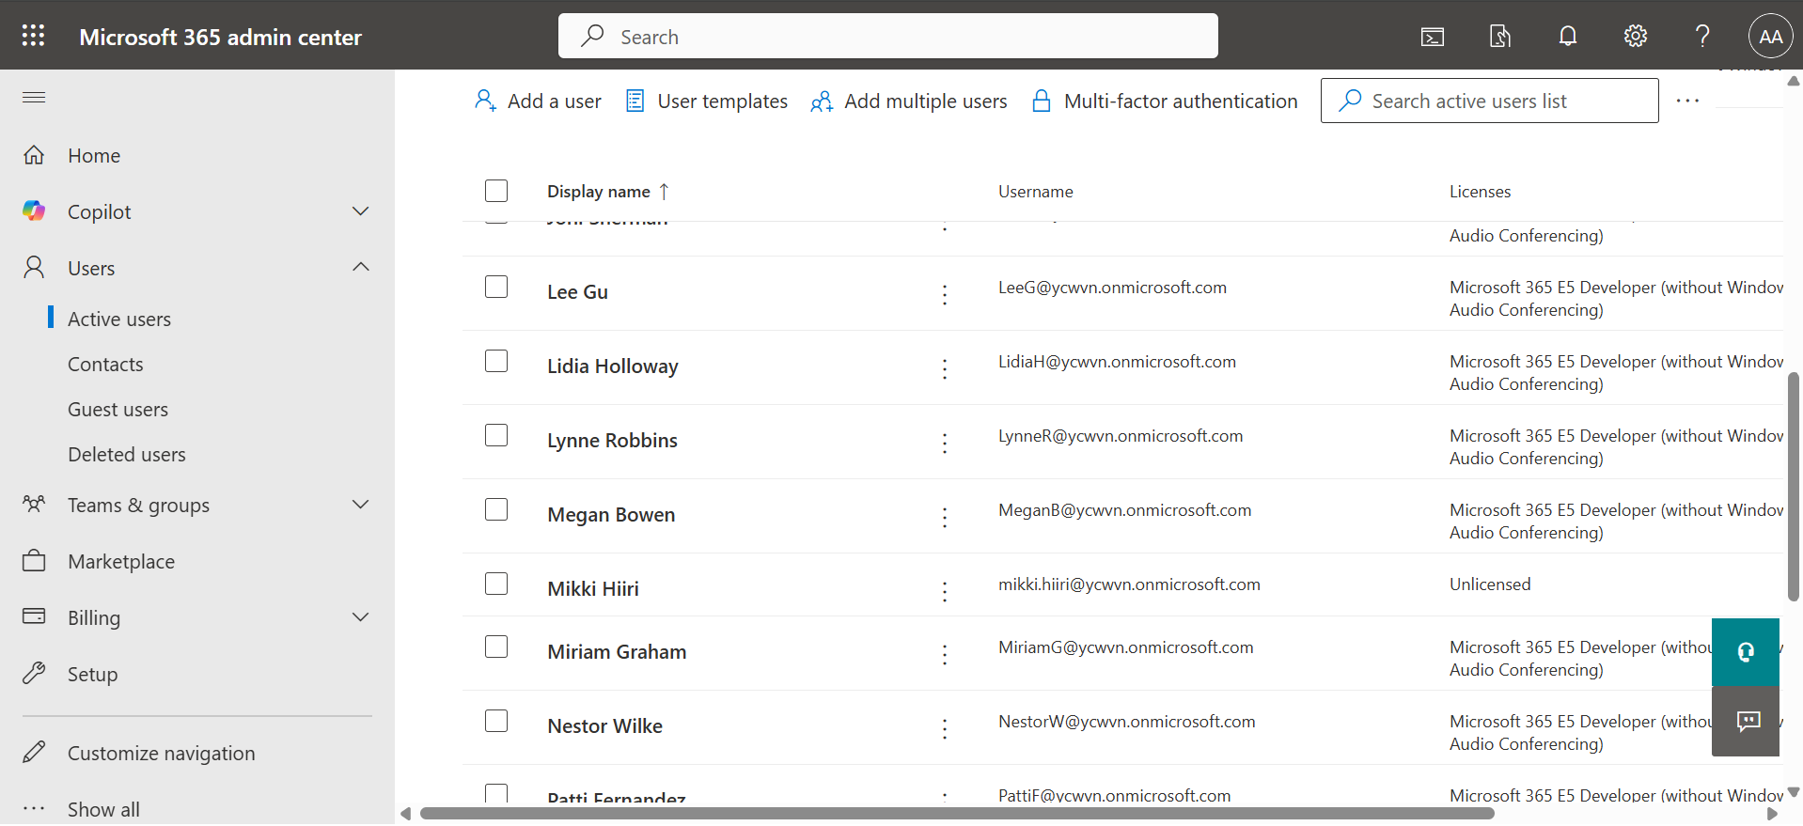

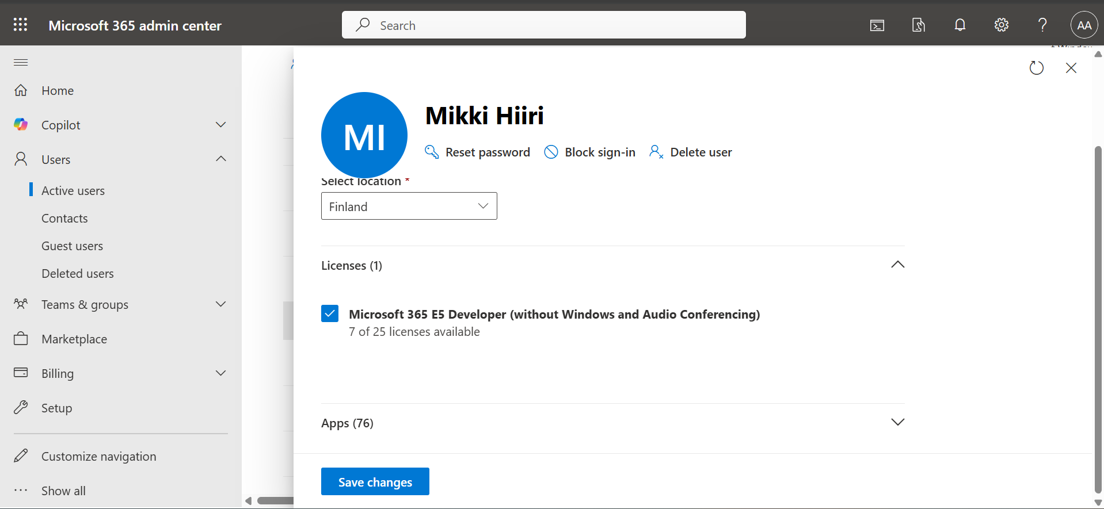

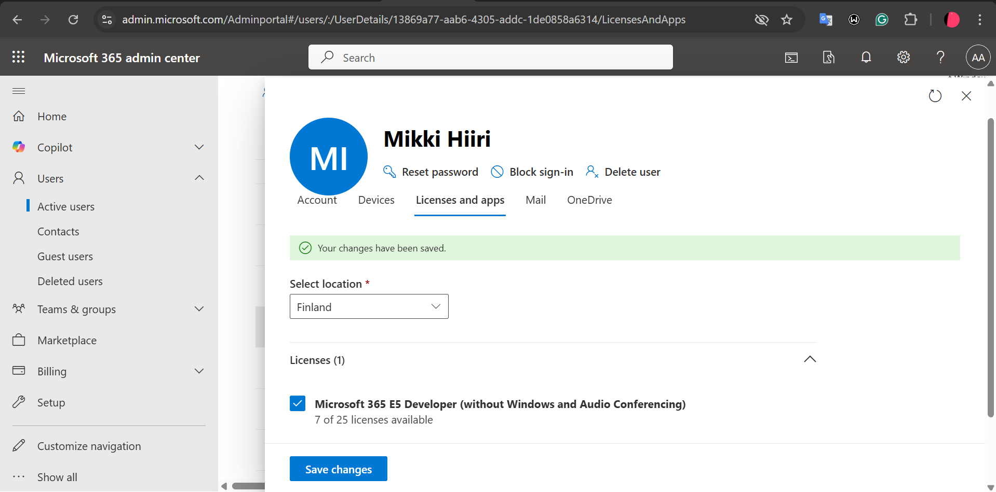

**Creating two new users**

1. **Alexander Jokinen**

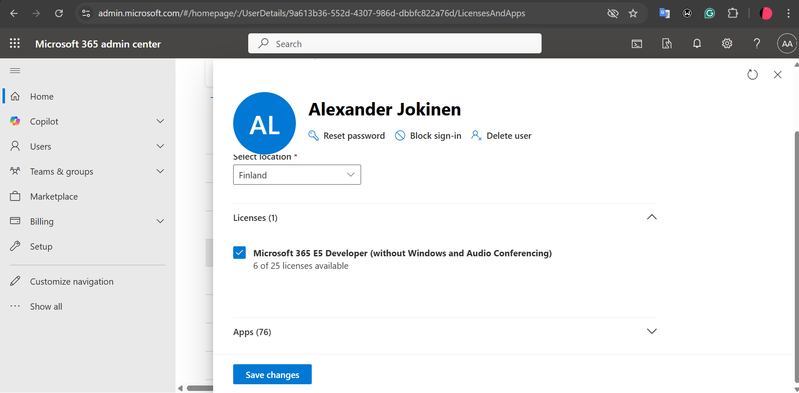

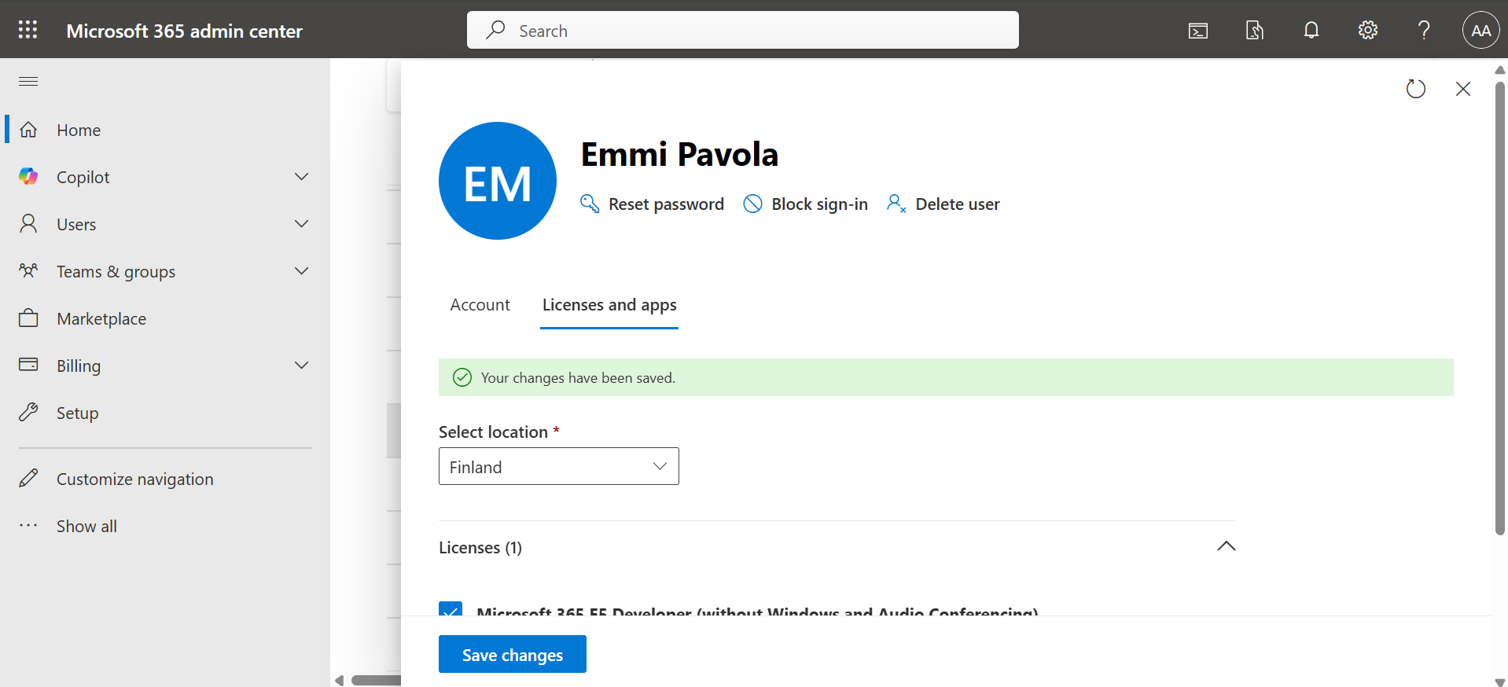

## Device Enrollment and Management Configuration

Microsoft Entra ID and Microsoft Intune were configured to allow devices to join the tenant and enroll into Intune for centralized management. Device join and registration settings enable users to onboard Windows devices, while the Intune MDM user scope ensures enrolled devices are automatically managed, allowing policies, compliance settings, and applications to be applied.

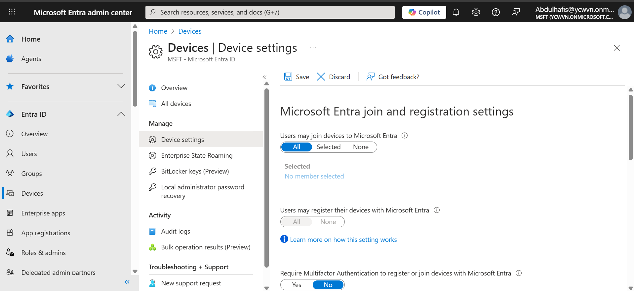

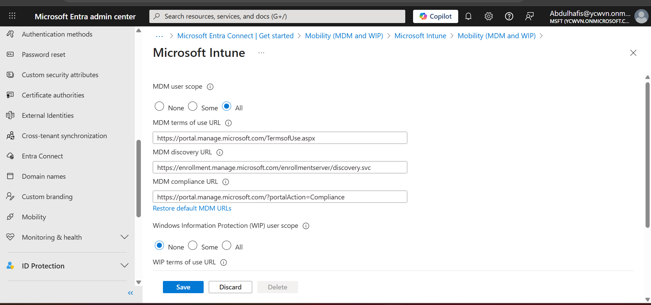

## Dynamic Device Group Configuration

A dynamic device group was created in Microsoft Intune to automatically include Windows 10 devices based on defined membership rules.

This group was used to assign policies, applications, and enrollment profiles, reducing the need for manual device management.

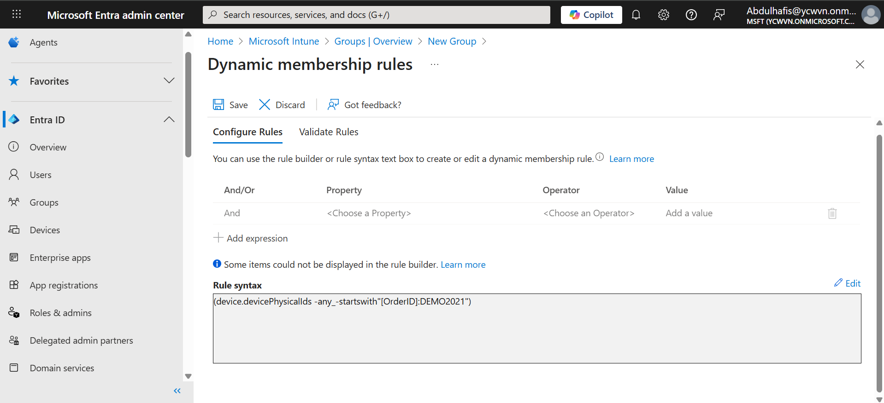

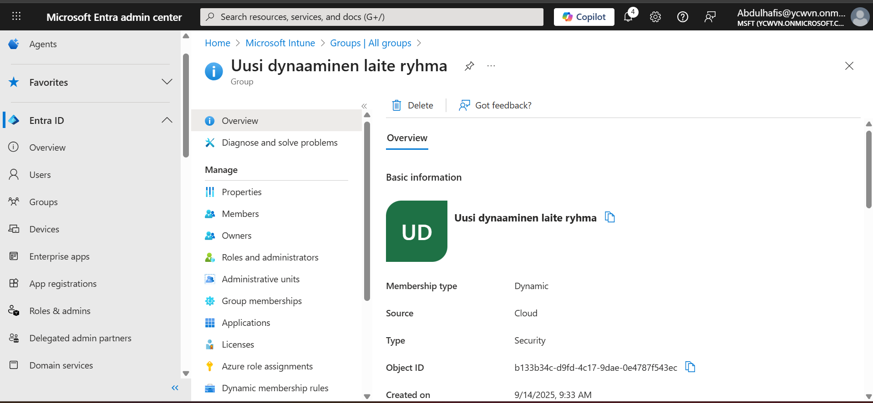

## Device Deployment Environment

A Windows 10 virtual machine was deployed using VMware vSphere. The VM was used as a test client to validate enrollment, policy assignment, and application deployment through Intune.

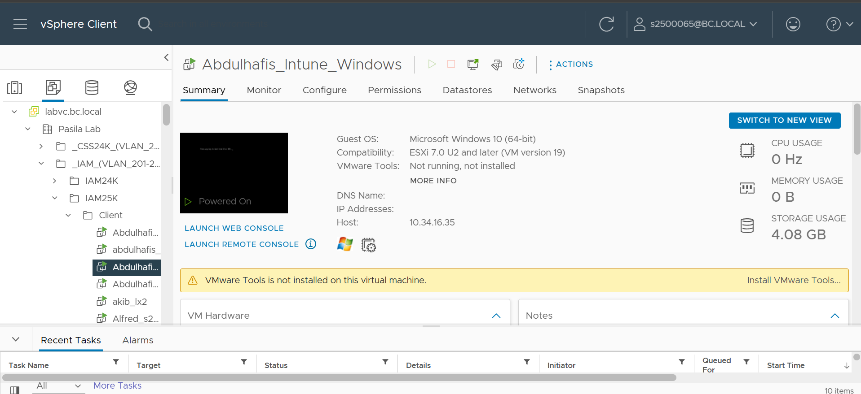

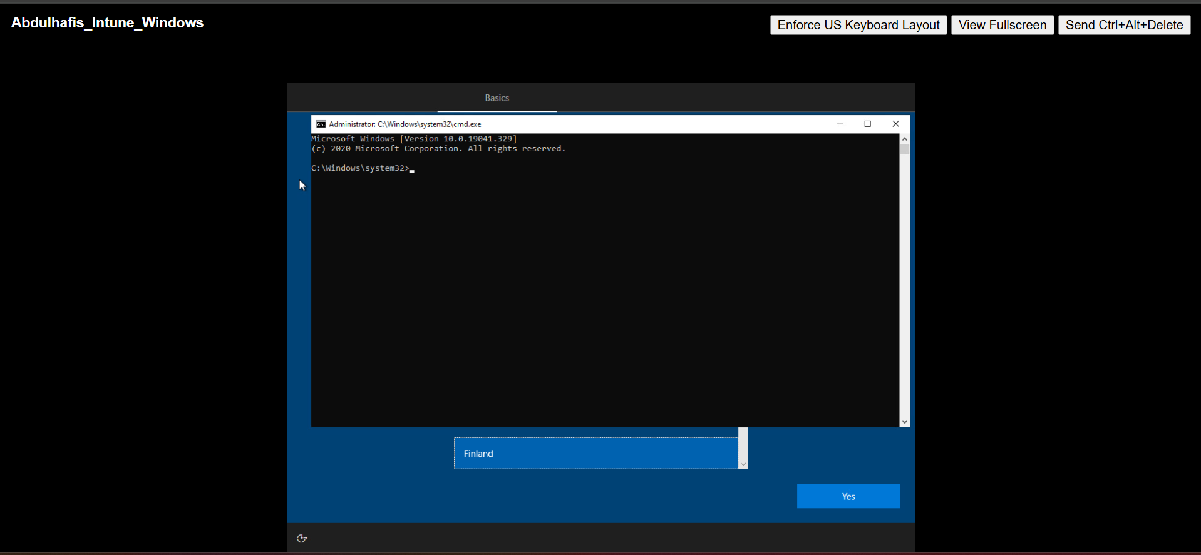

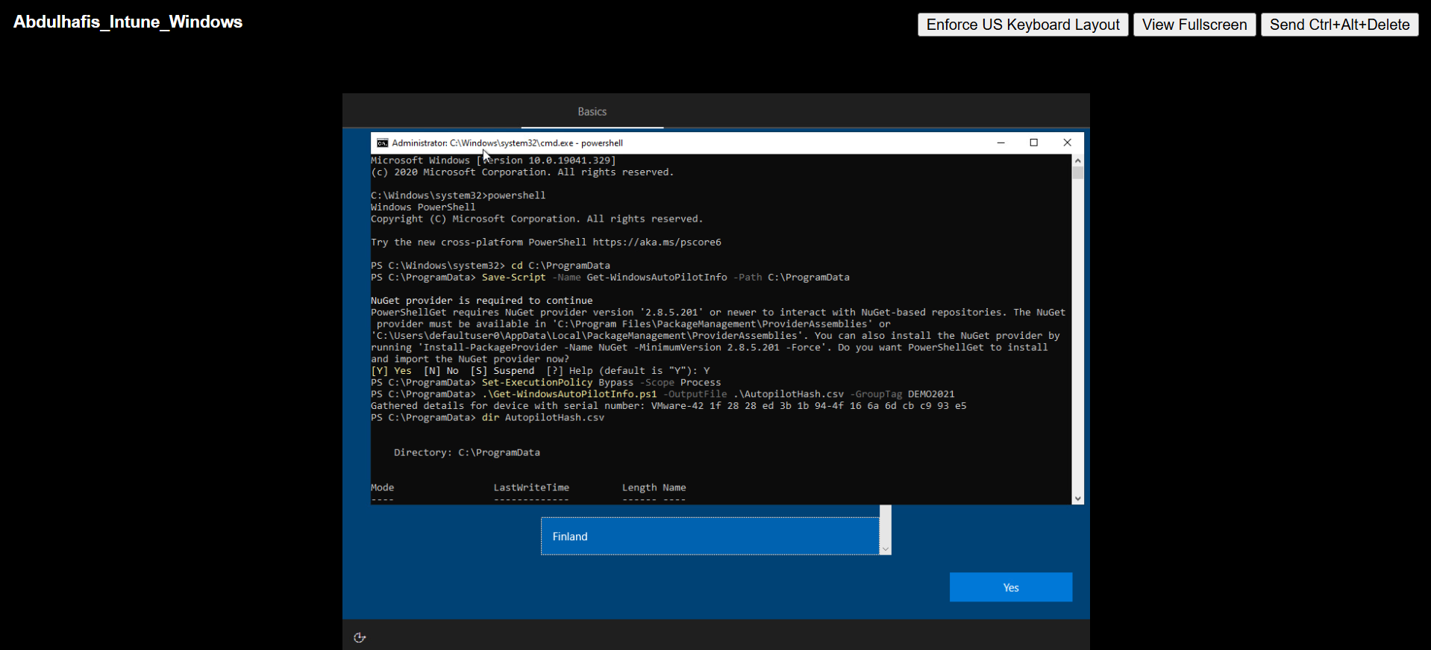

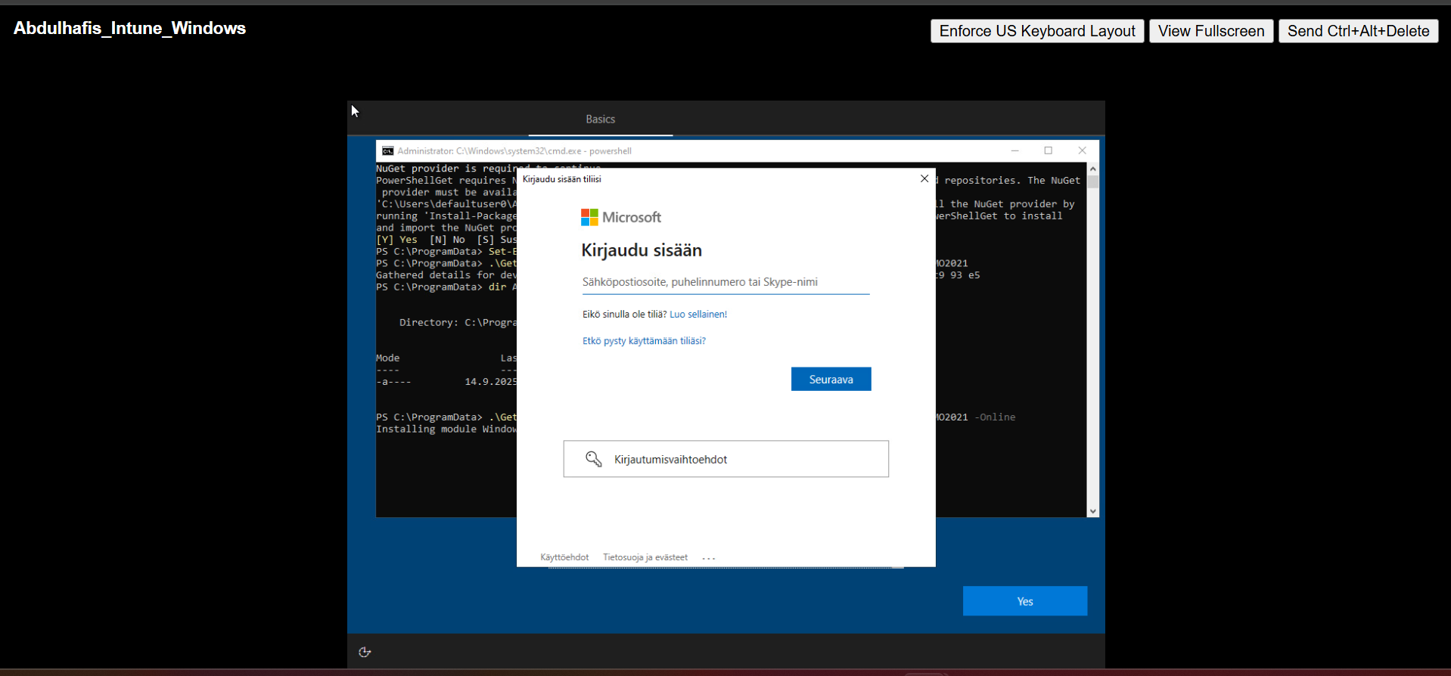

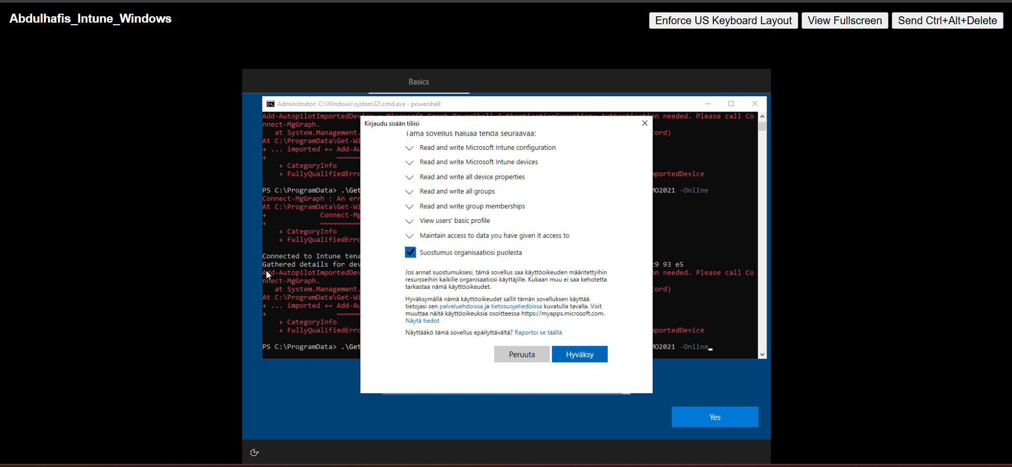

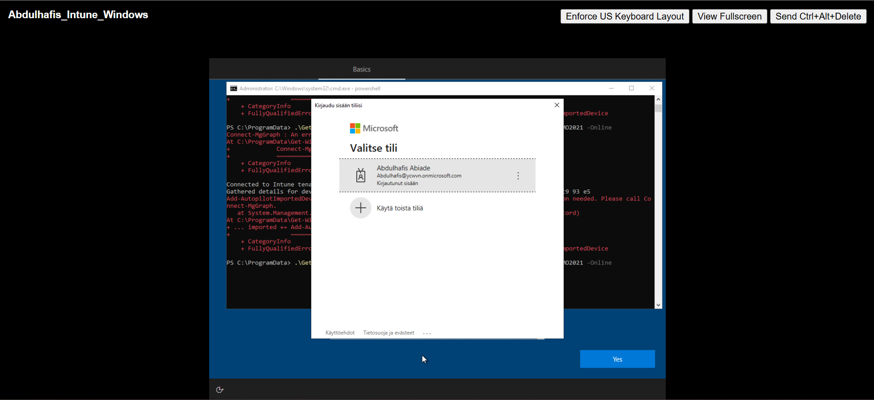

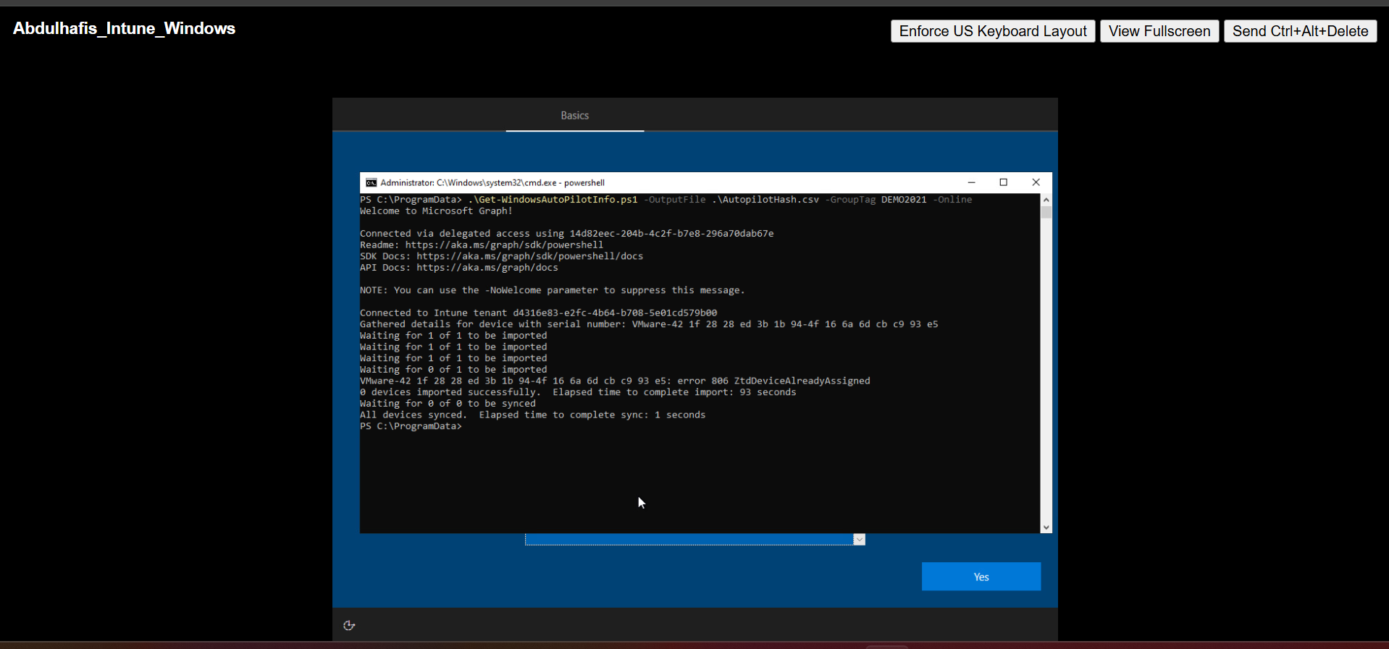

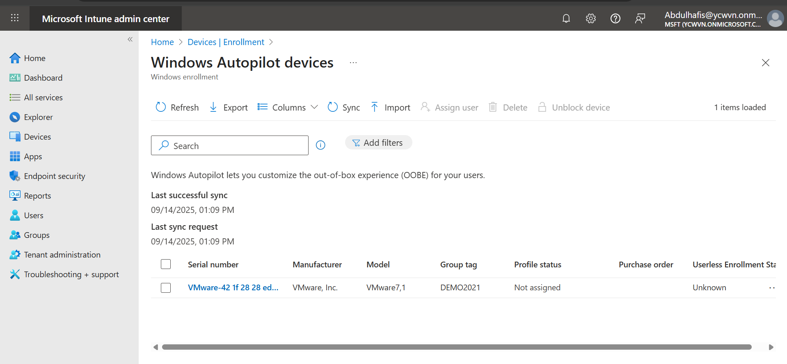

## Application Deployment Using Dynamic Device Groups

Applications were added to Microsoft Intune and assigned to a dynamic device group to enable automated deployment. By targeting the dynamic group, applications such as Microsoft 365 Apps are installed automatically on enrolled Windows devices, ensuring consistent software delivery without manual user intervention.

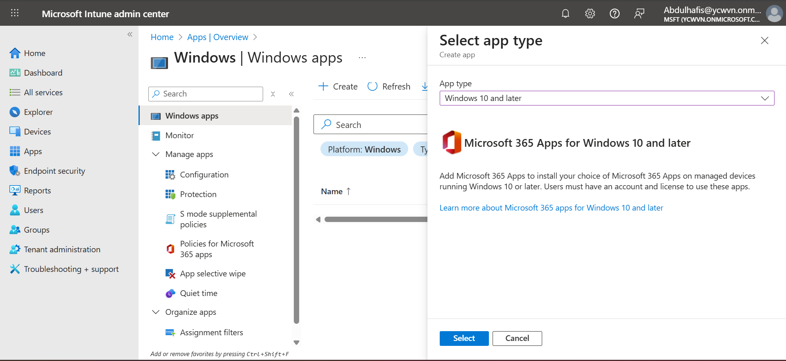

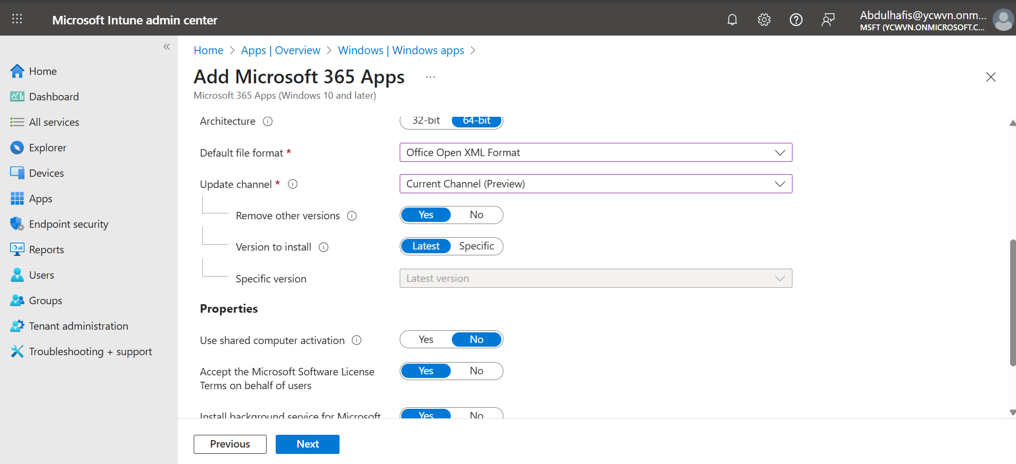

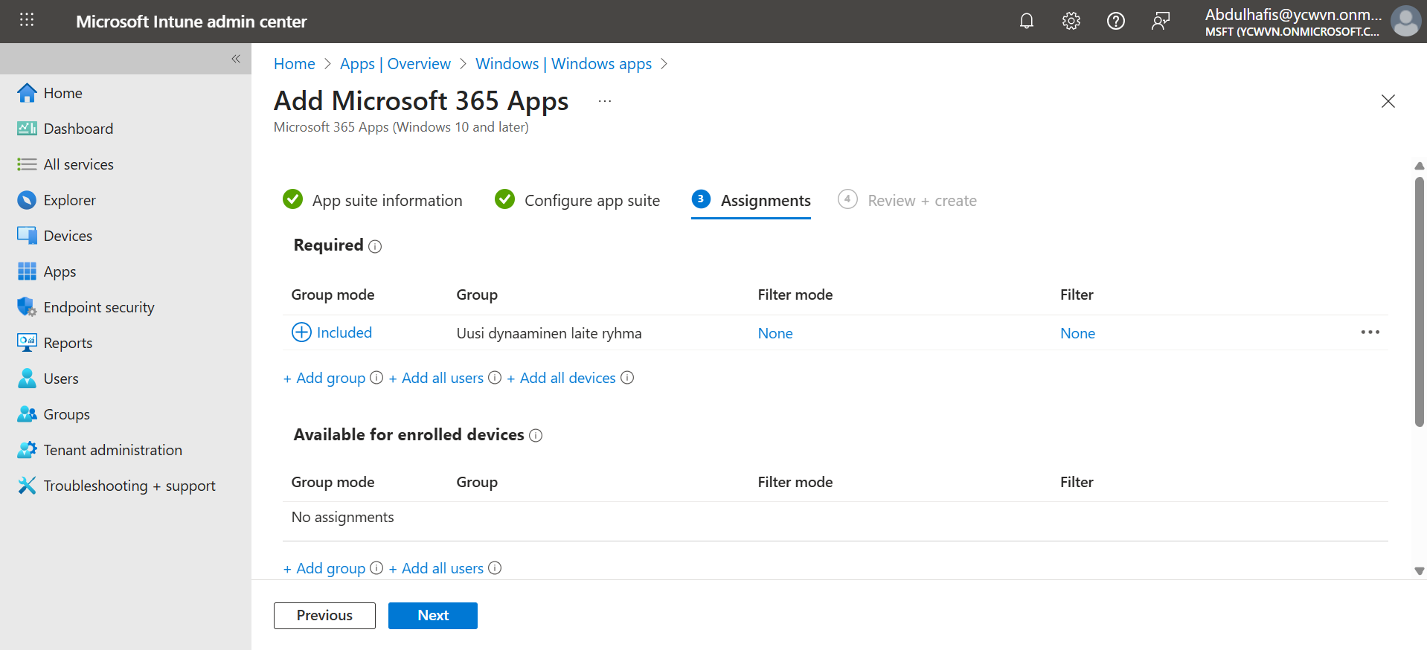

**Adding business store apps (now Microsoft store apps)**

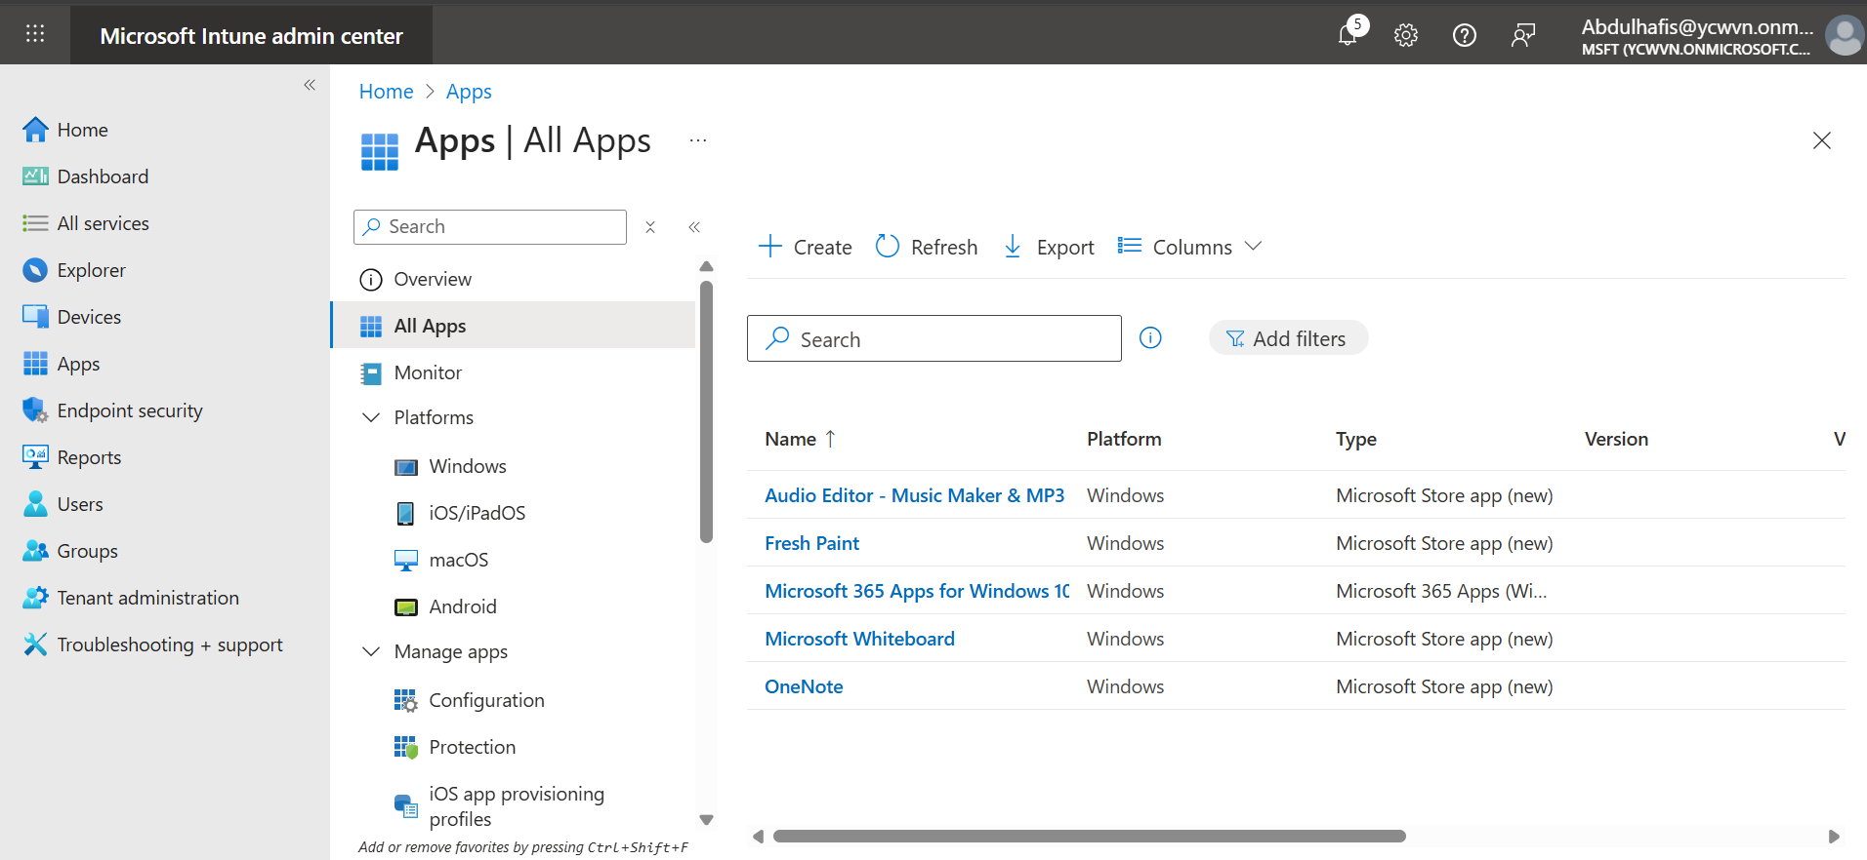

## Win32 Application Packaging and Deployment (7-Zip)

The 7-Zip application was packaged as a Win32 app using the Microsoft Intune Win32 Content Prep Tool and uploaded to Microsoft Intune. The application was configured with installation parameters and metadata, then assigned to a dynamic device group to enable automatic installation on enrolled Windows devices.

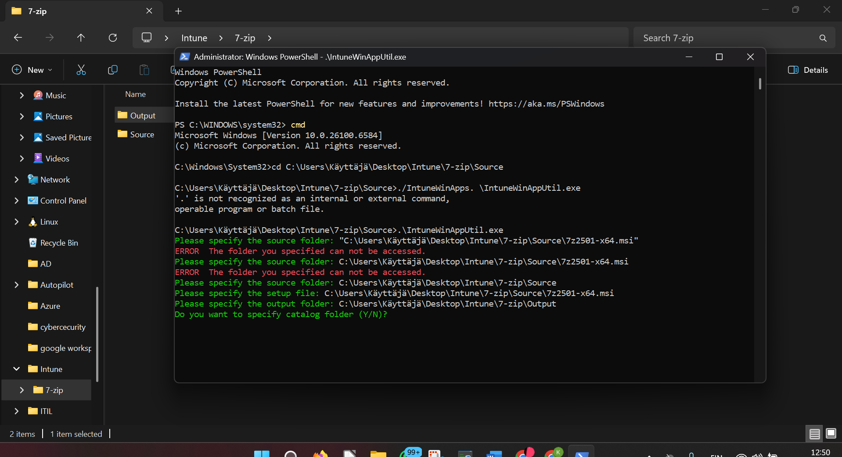

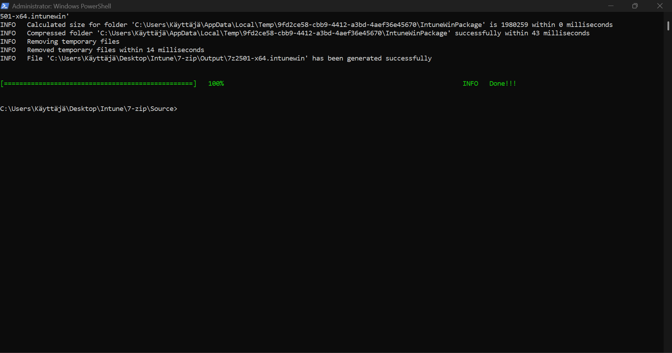

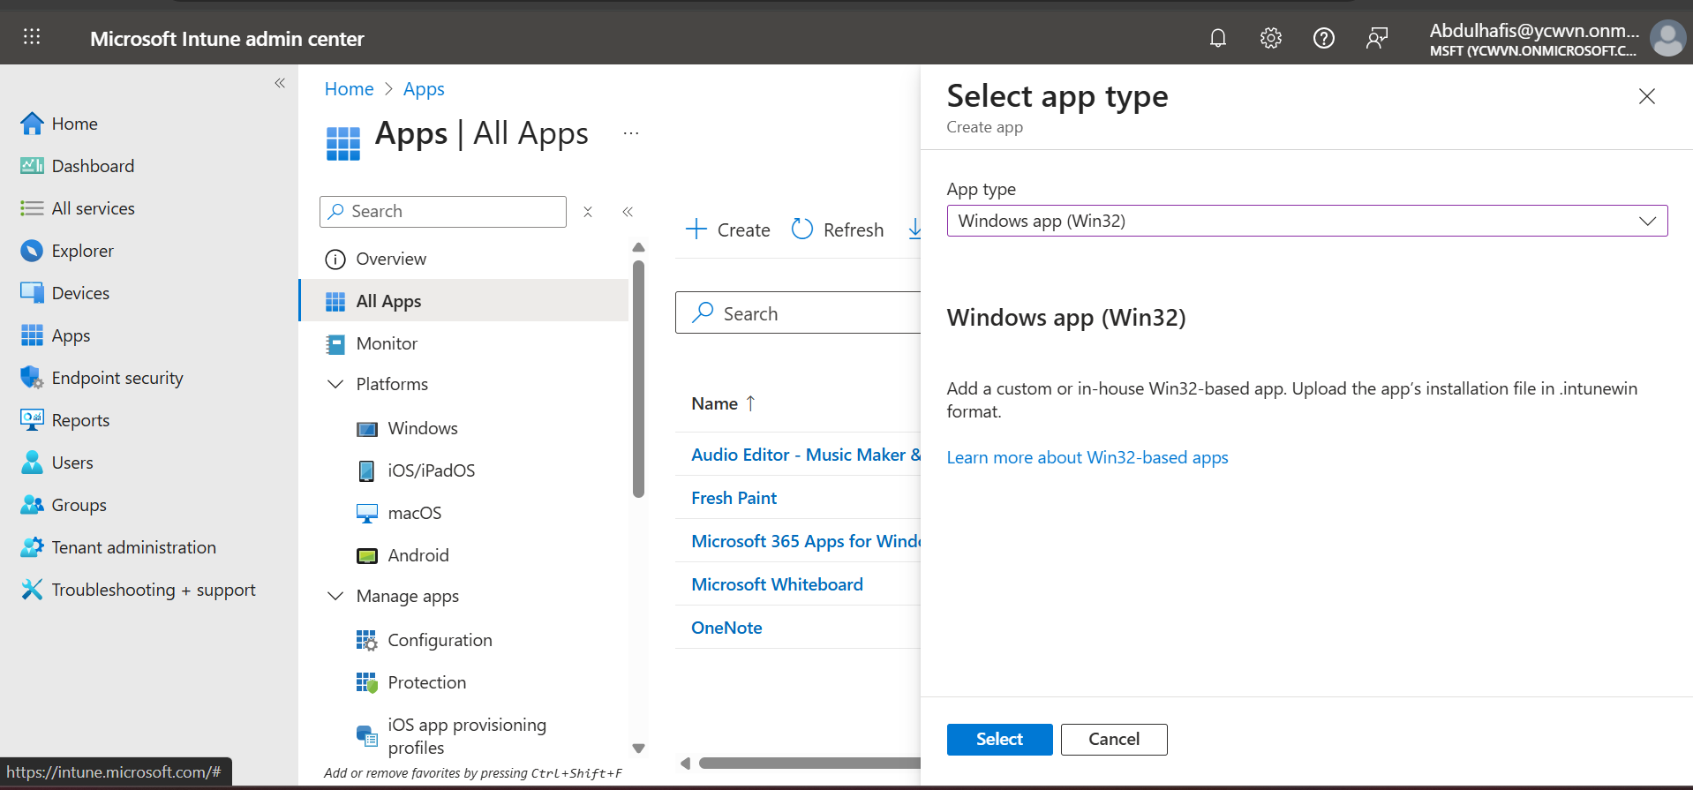

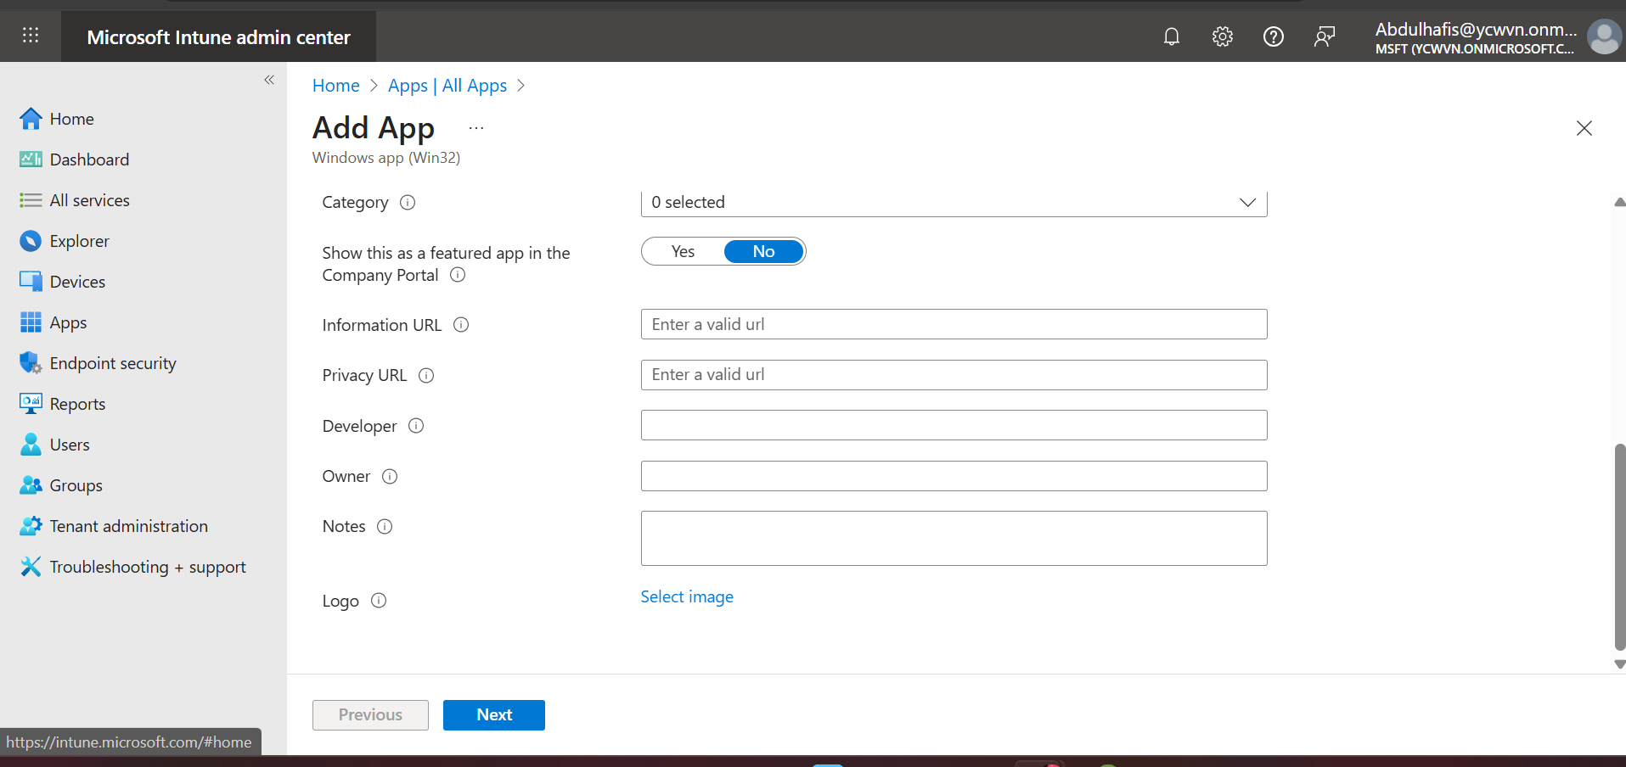

**7zip logo**

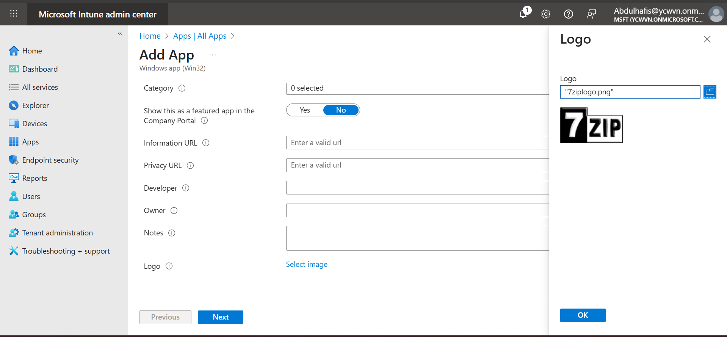

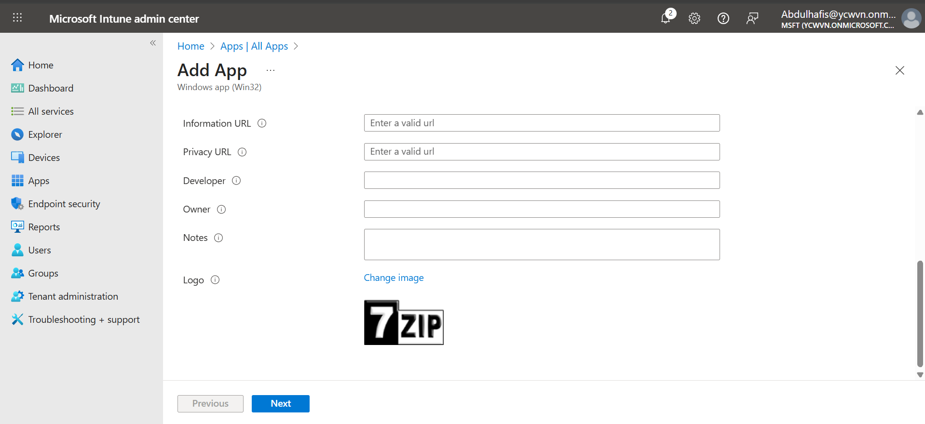

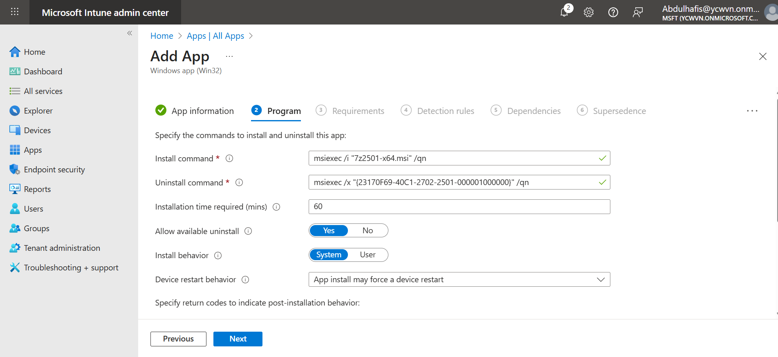

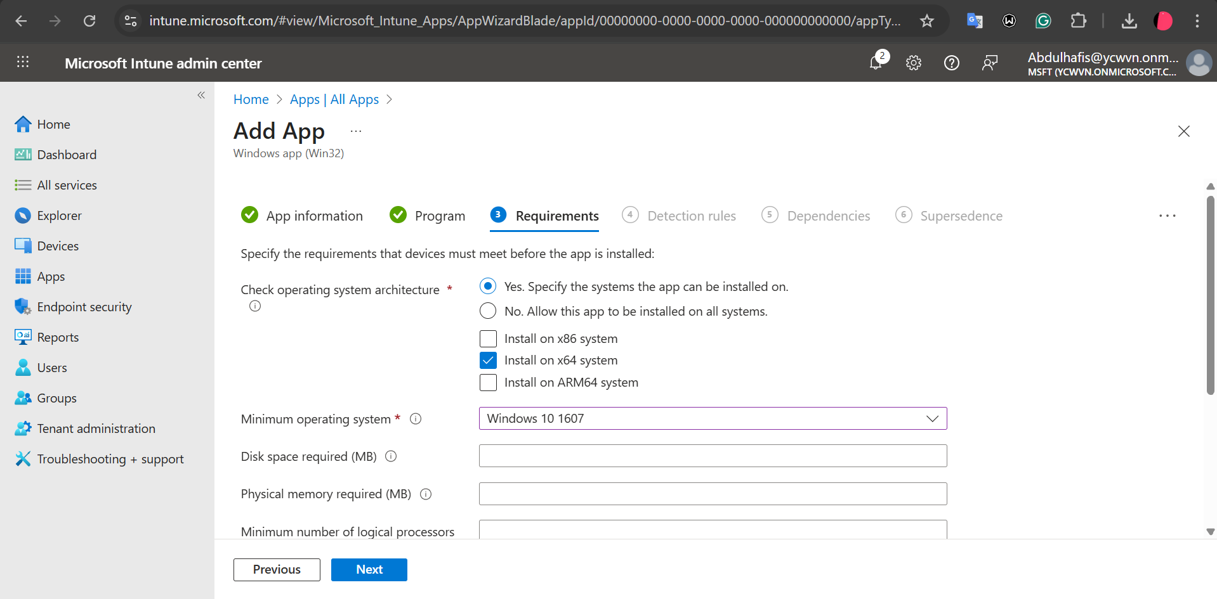

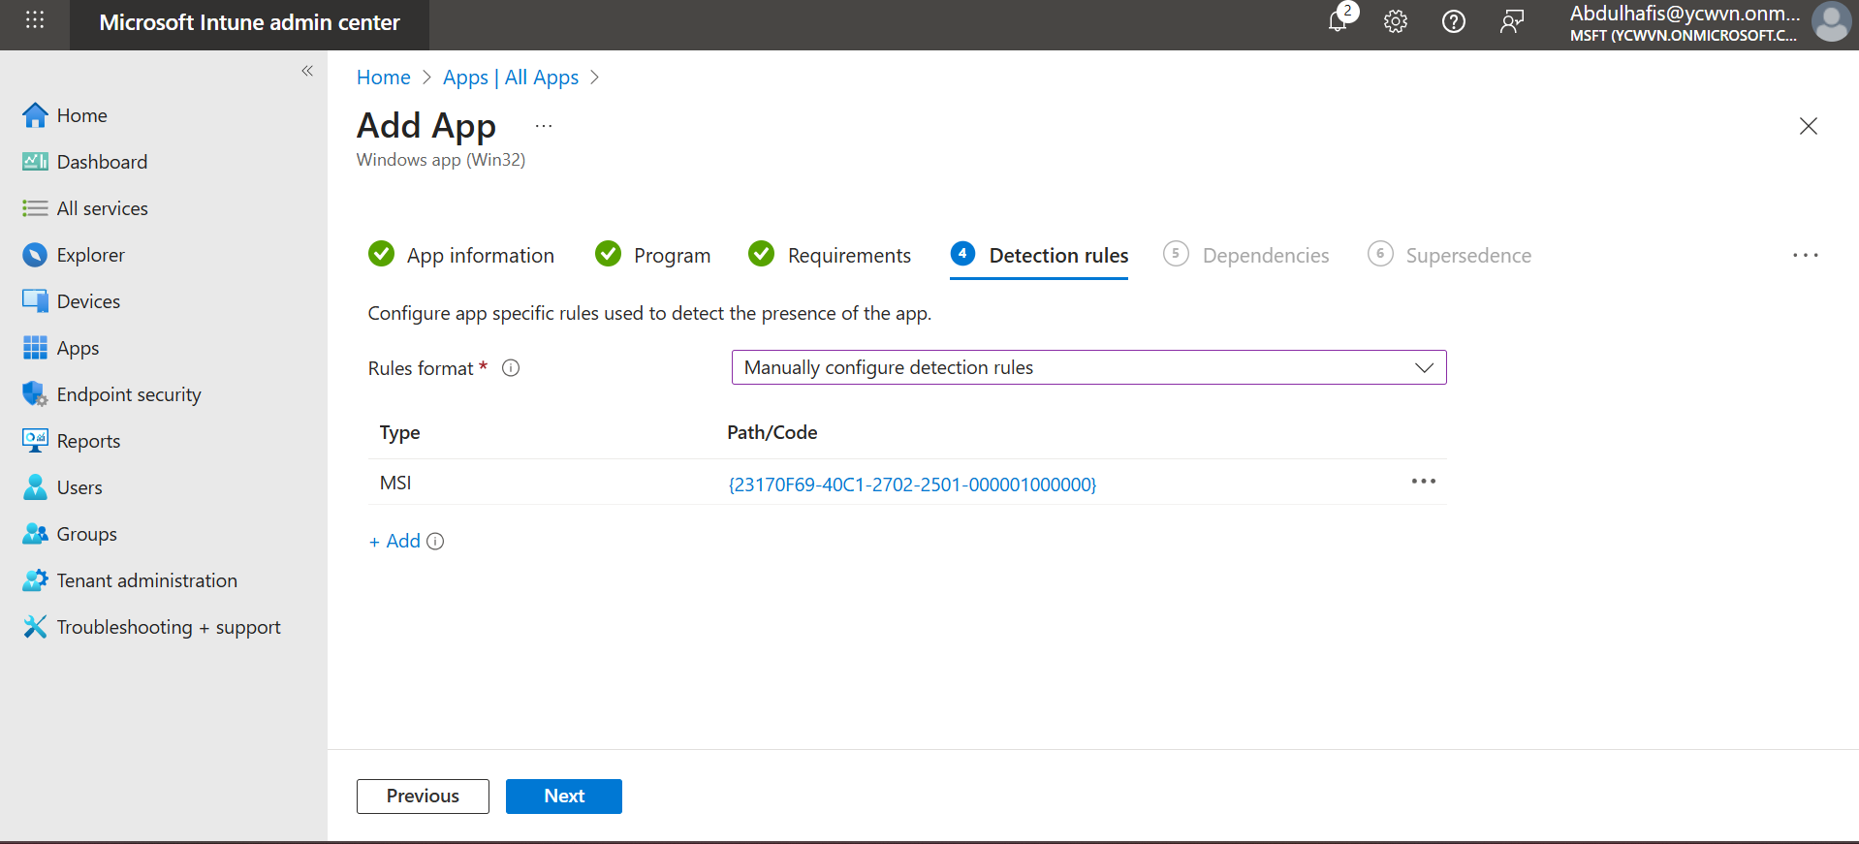

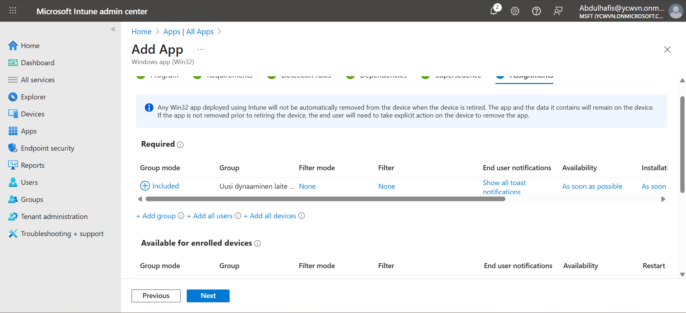

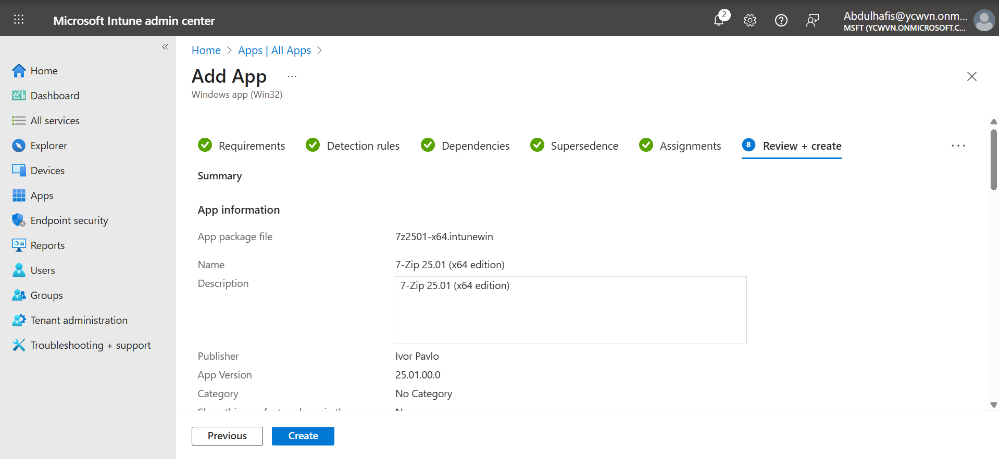

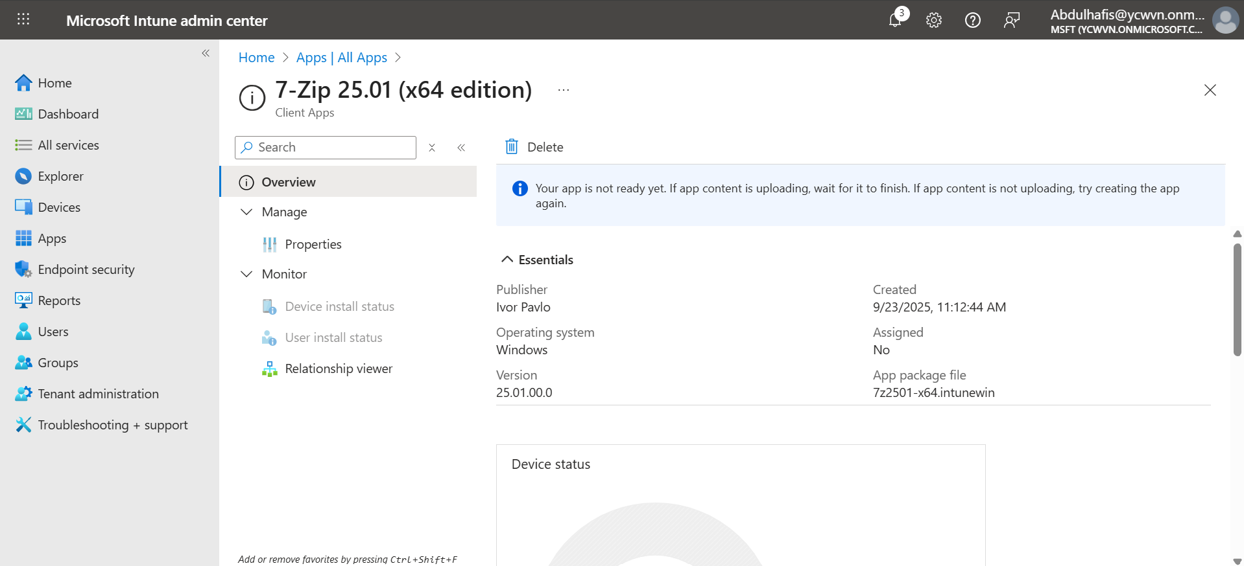

## Enrollment Profiles and Policy Assignment

Windows Autopilot was configured to automate device provisioning.  
The following profiles were assigned to the dynamic device group:

* Windows Autopilot Deployment Profile
* Enrollment Status Page (ESP)
* Enrollment Restrictions
* Configuration Profiles
* Compliance Policies

During enrollment, the device was automatically registered in Entra ID and enrolled into Intune.

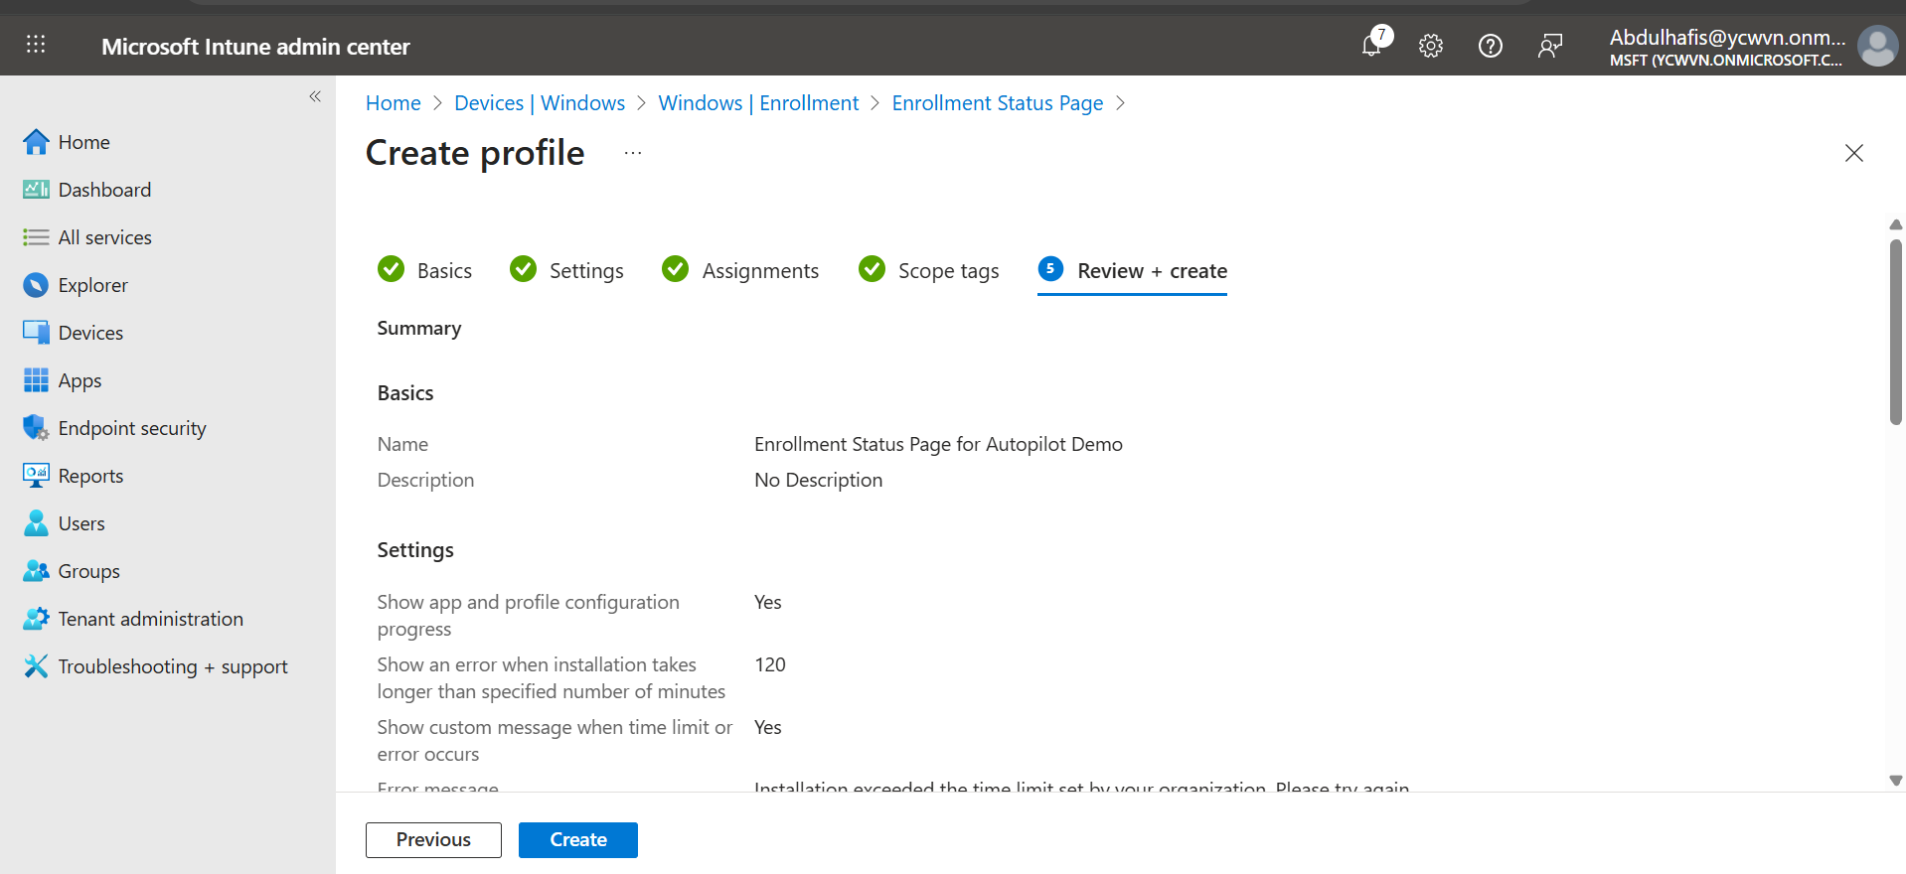

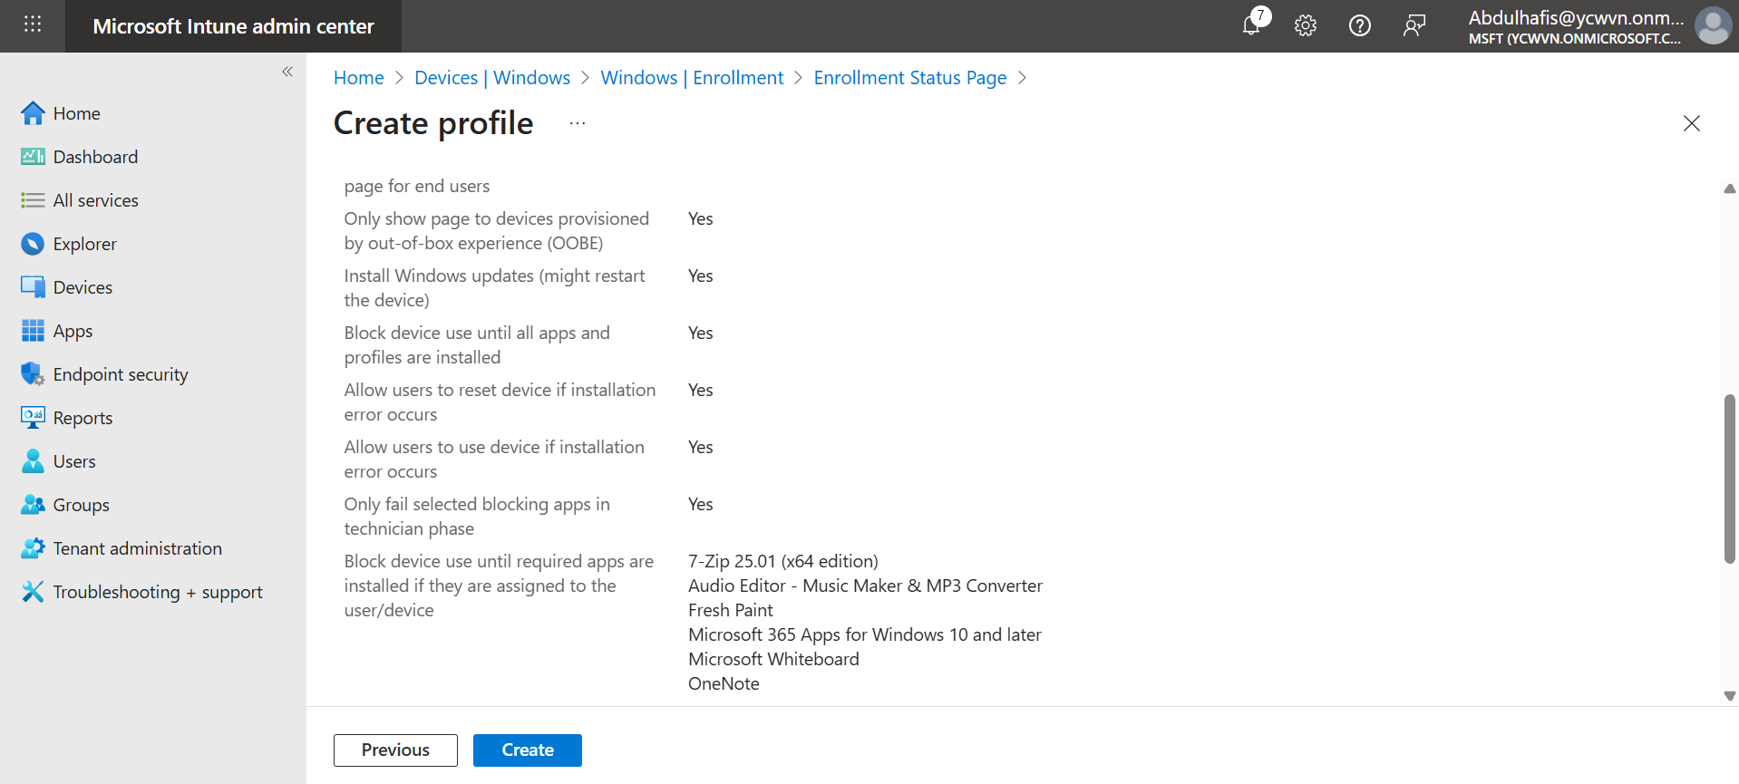

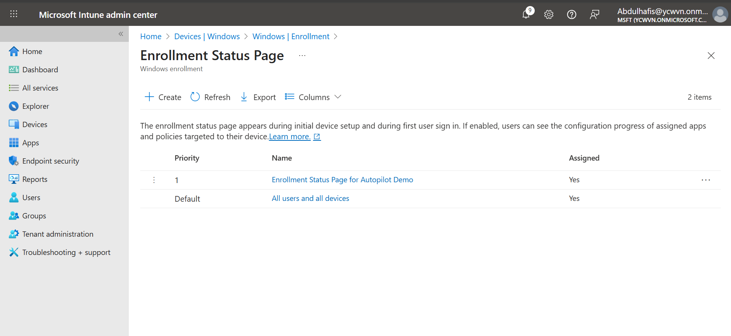

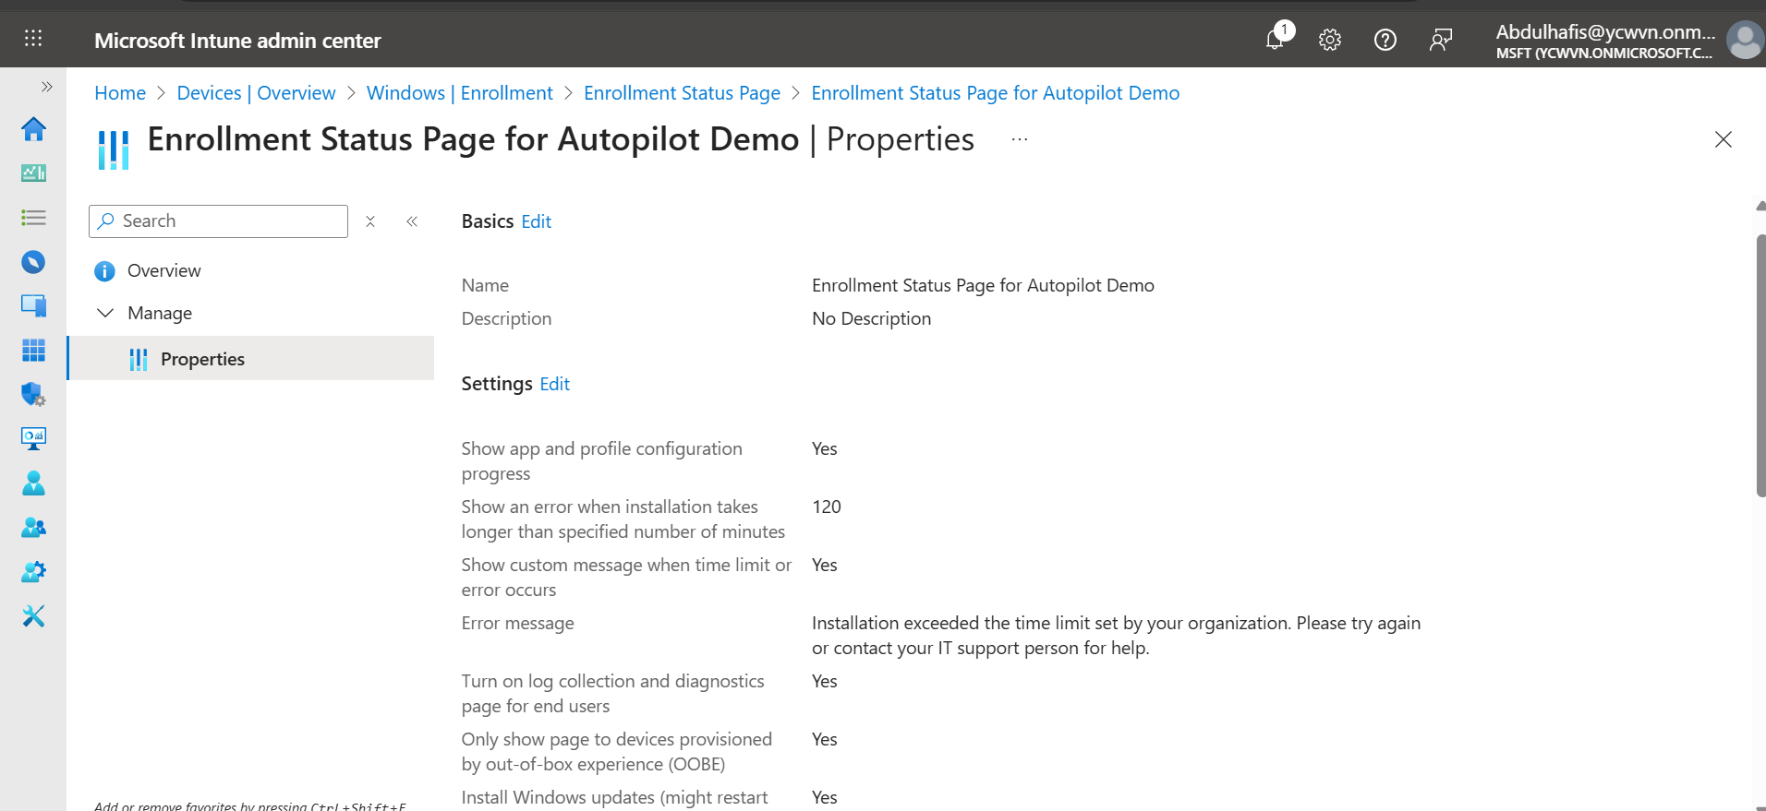

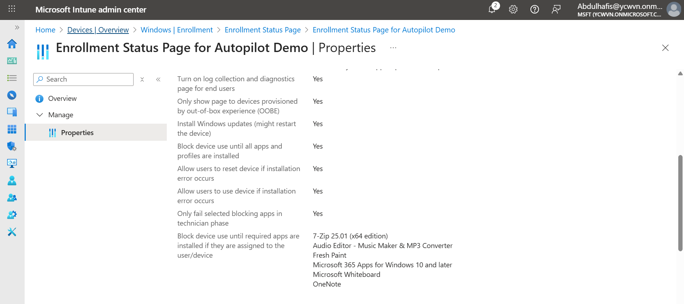

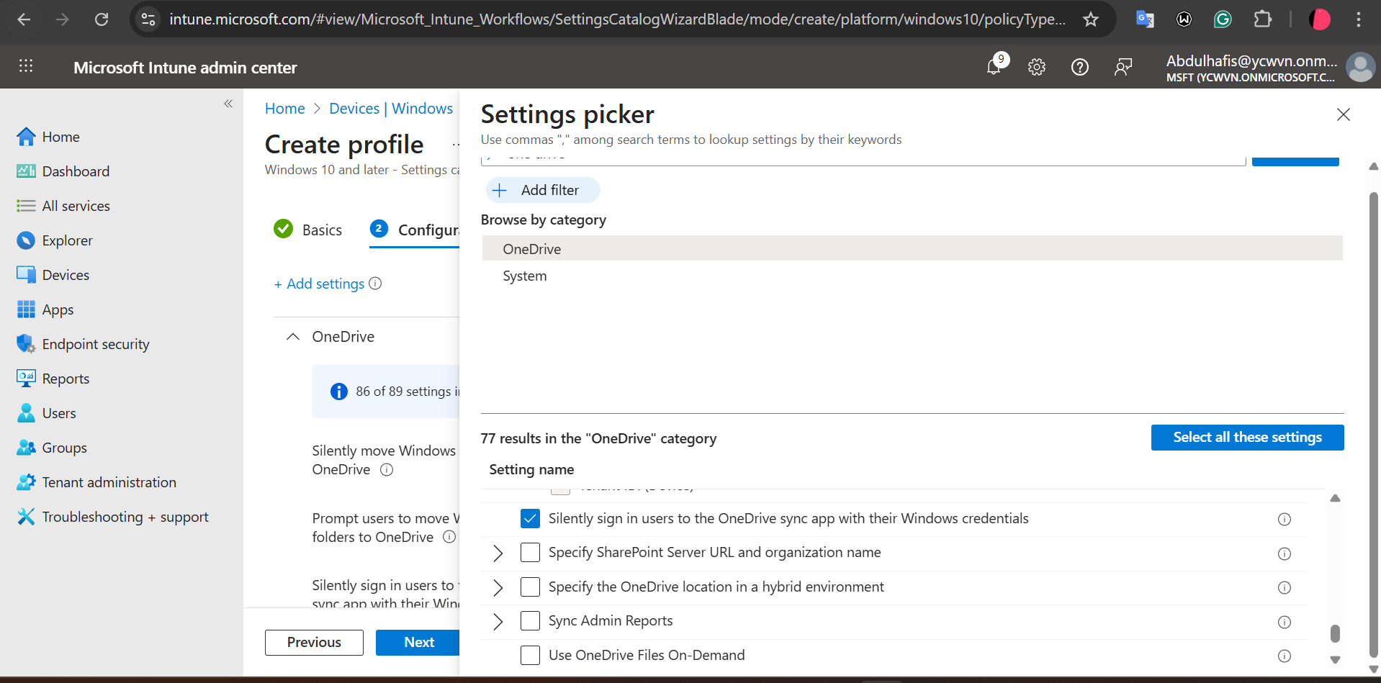

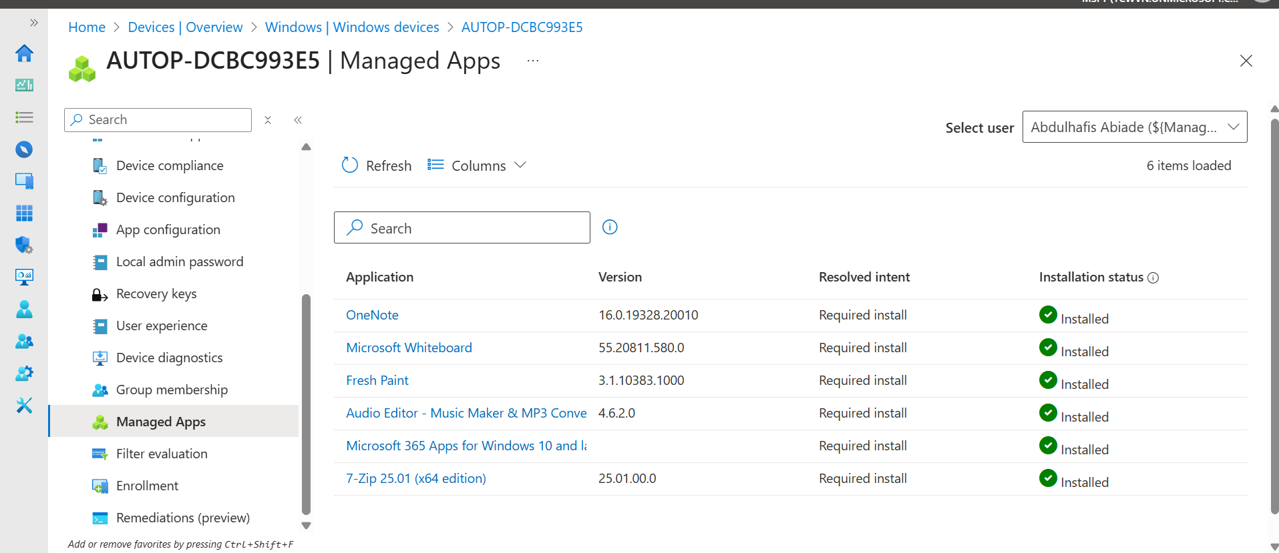

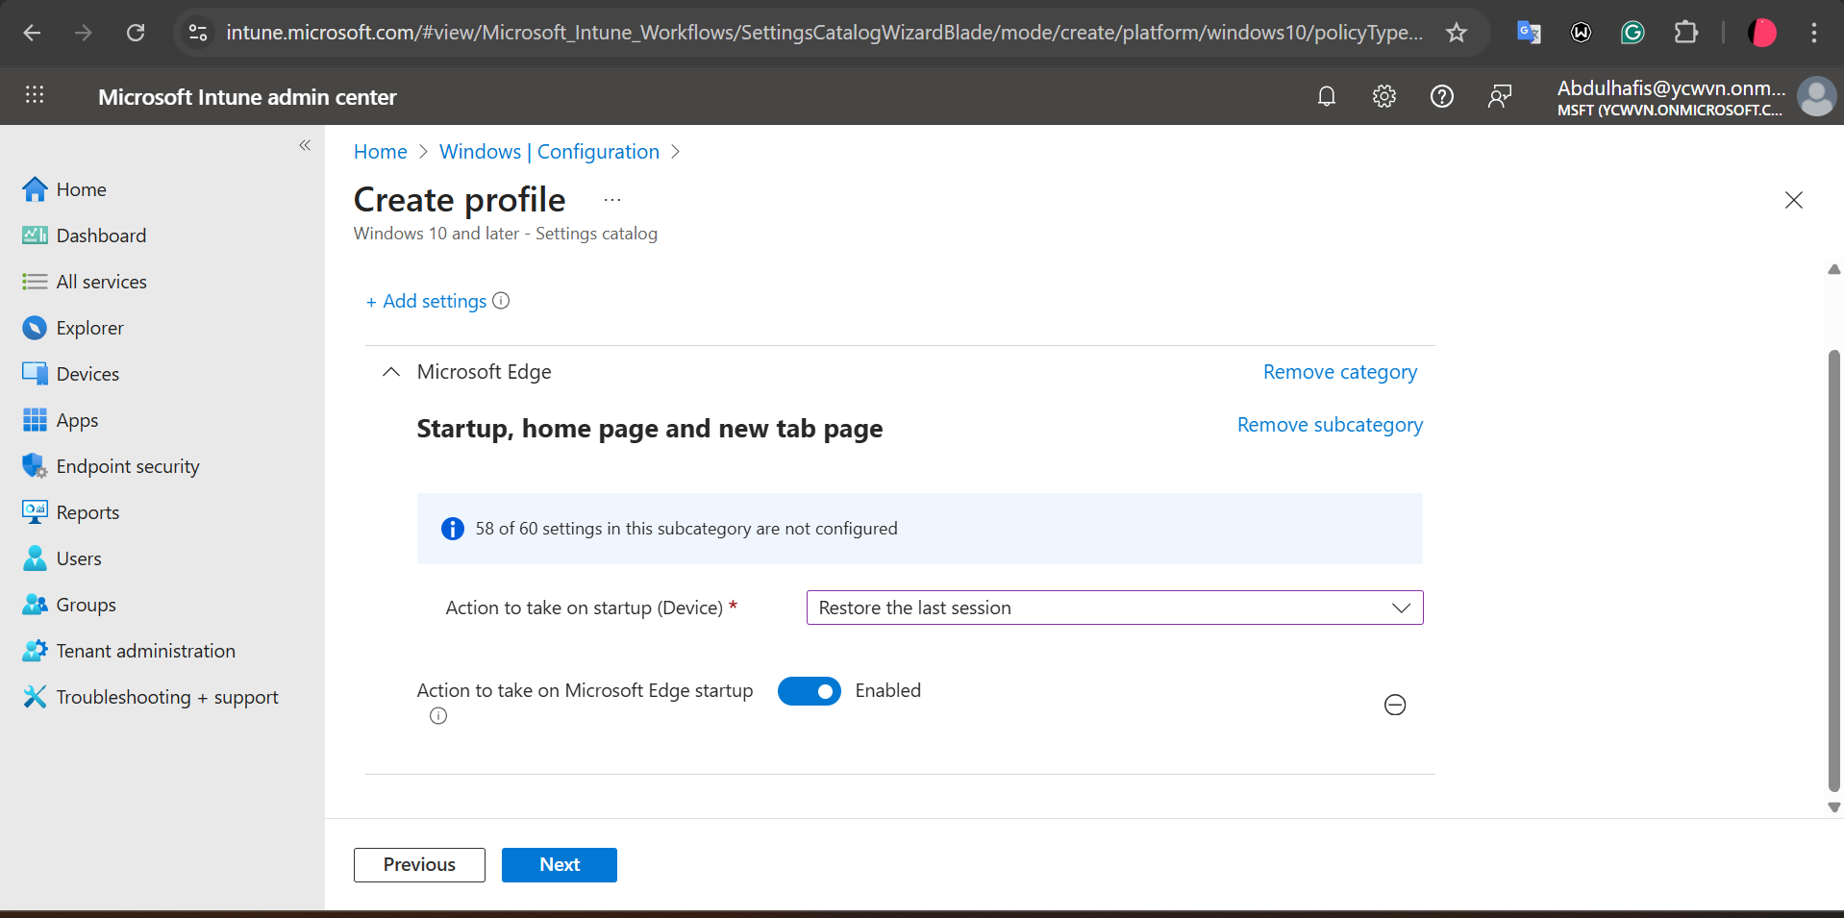

**Configuration settings**

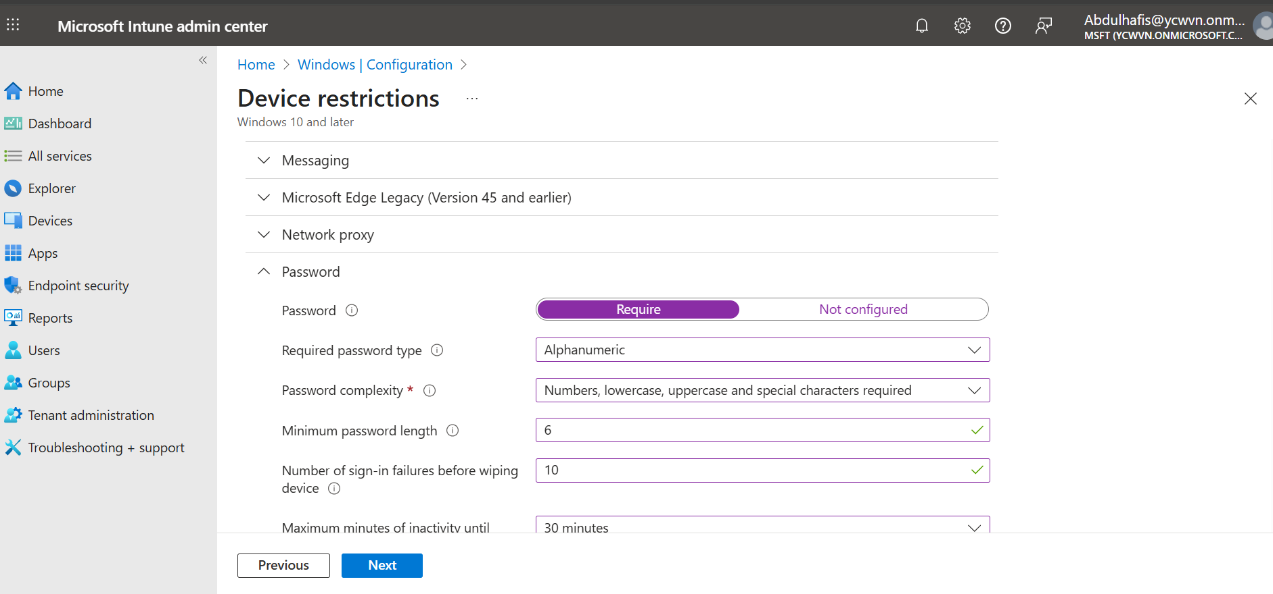

**Enrollment**

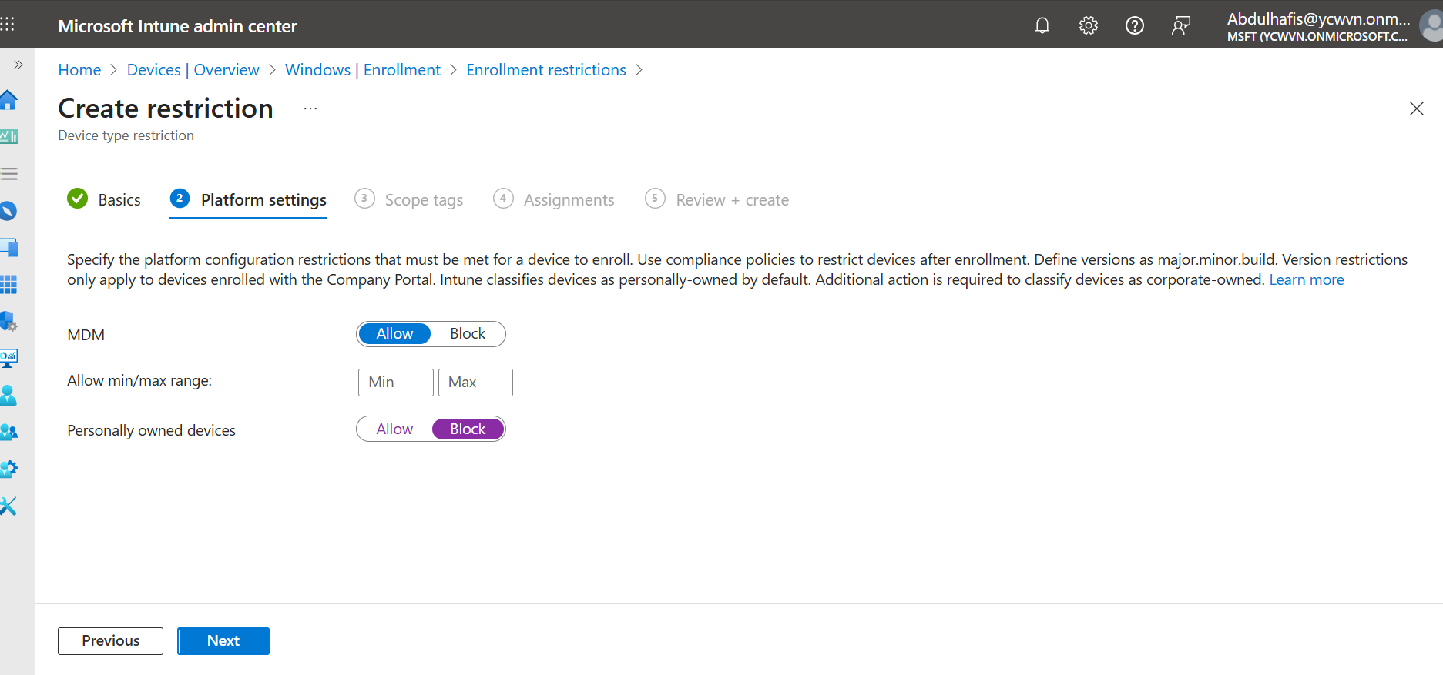

**Compliance**

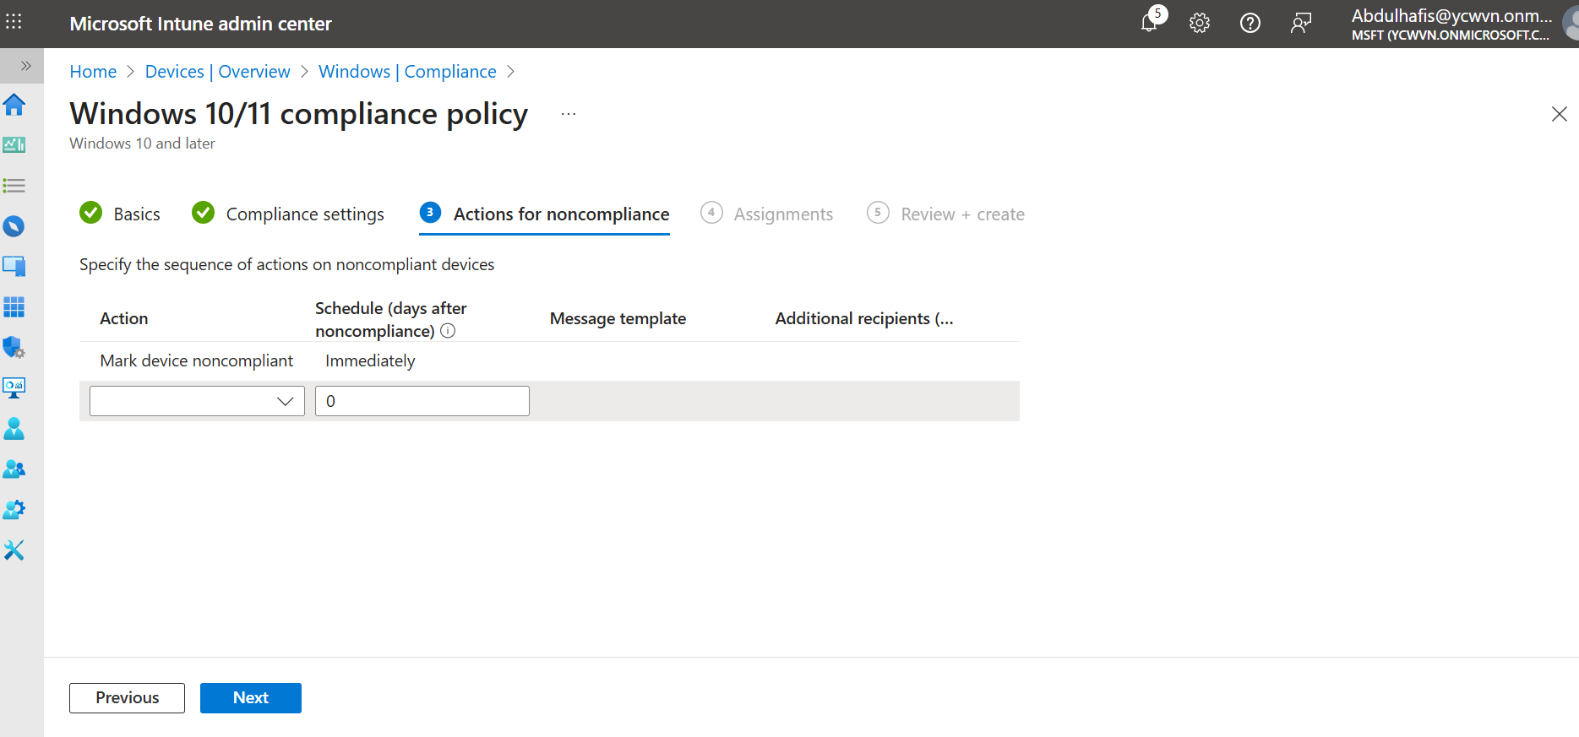

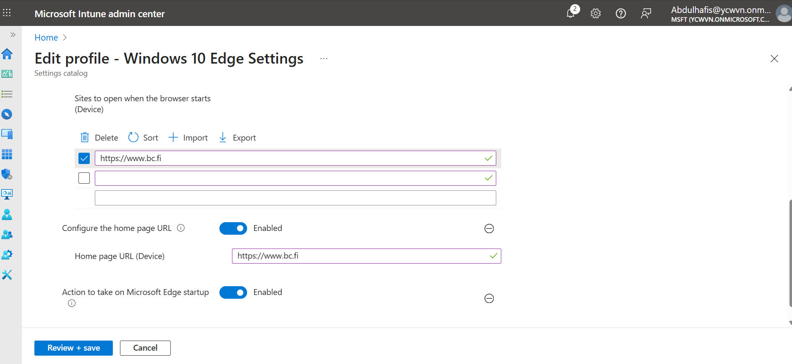

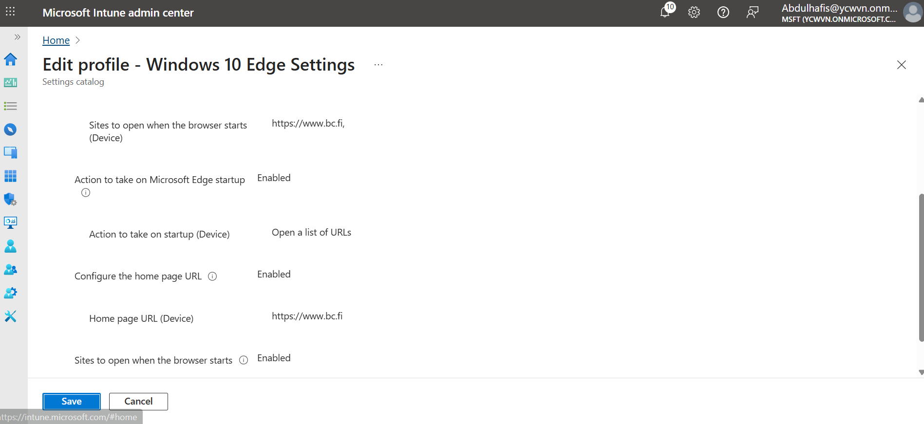

Automated Device Provisioning via Intune

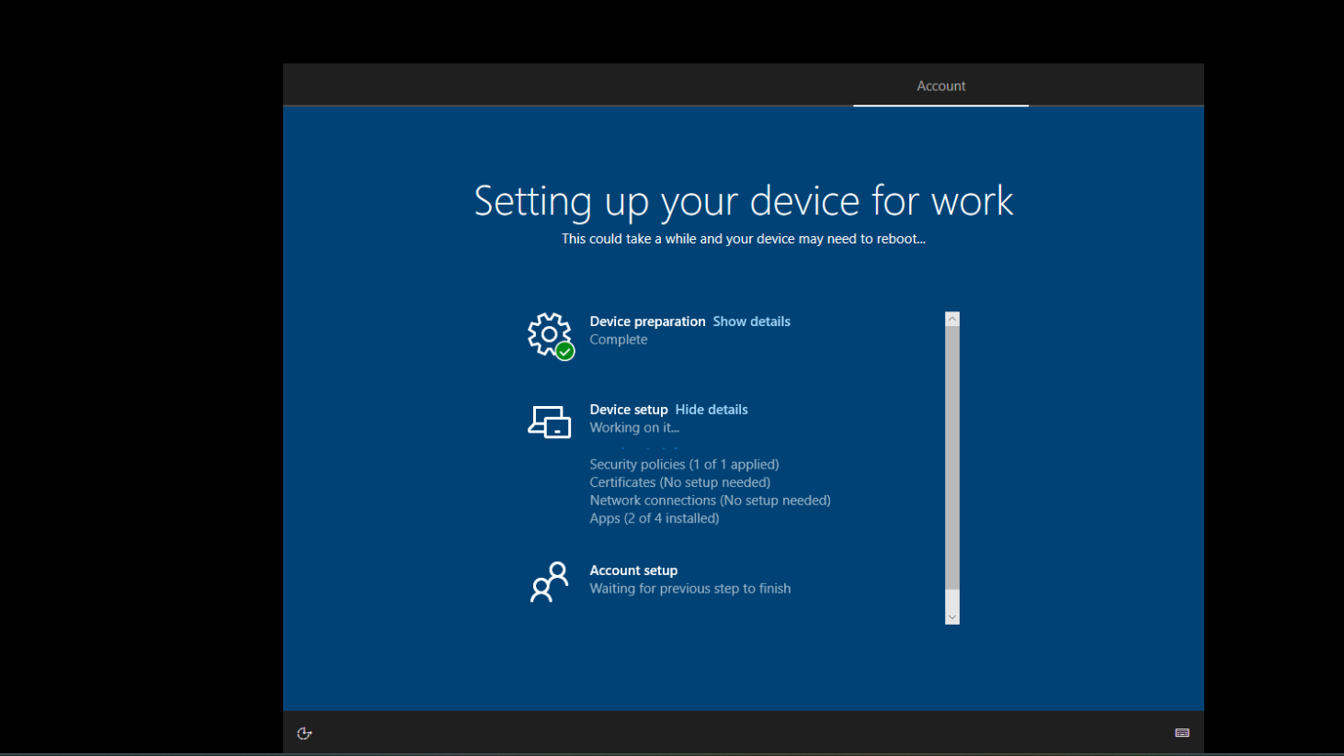

## Results

* Device successfully enrolled into Intune
* Policies applied automatically
* Applications installed without user interaction
* Browser settings enforced through configuration profiles
* End-to-end device provisioning validated

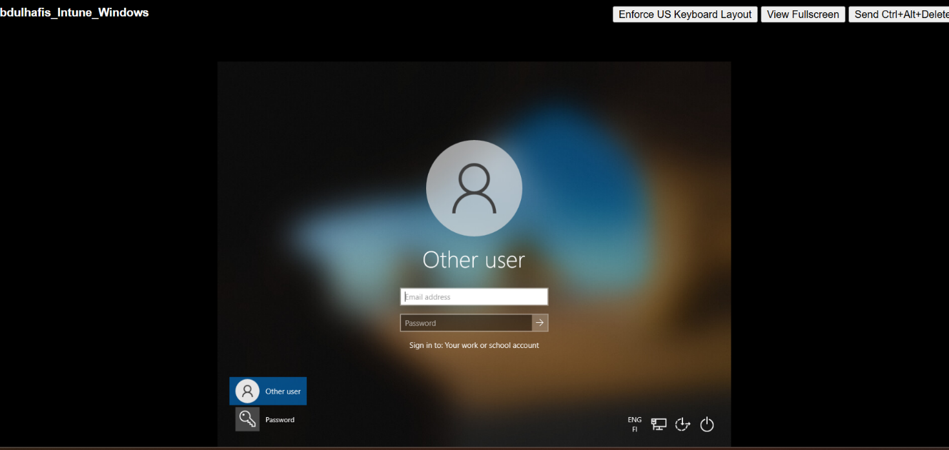

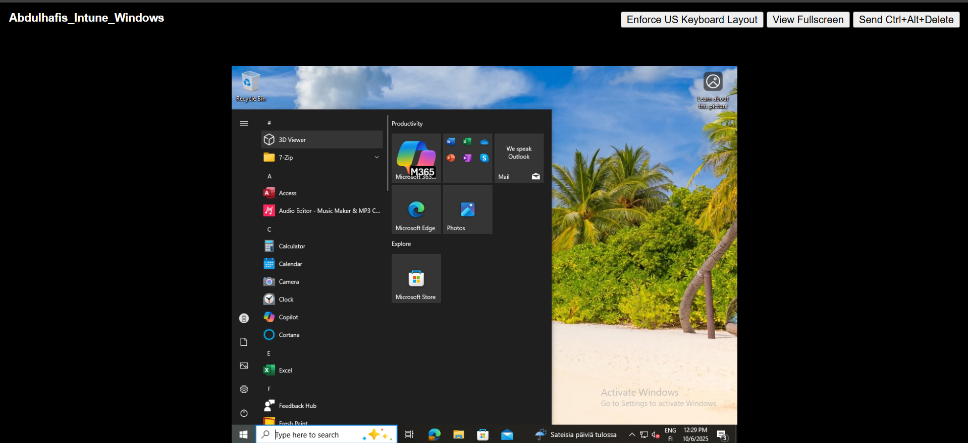

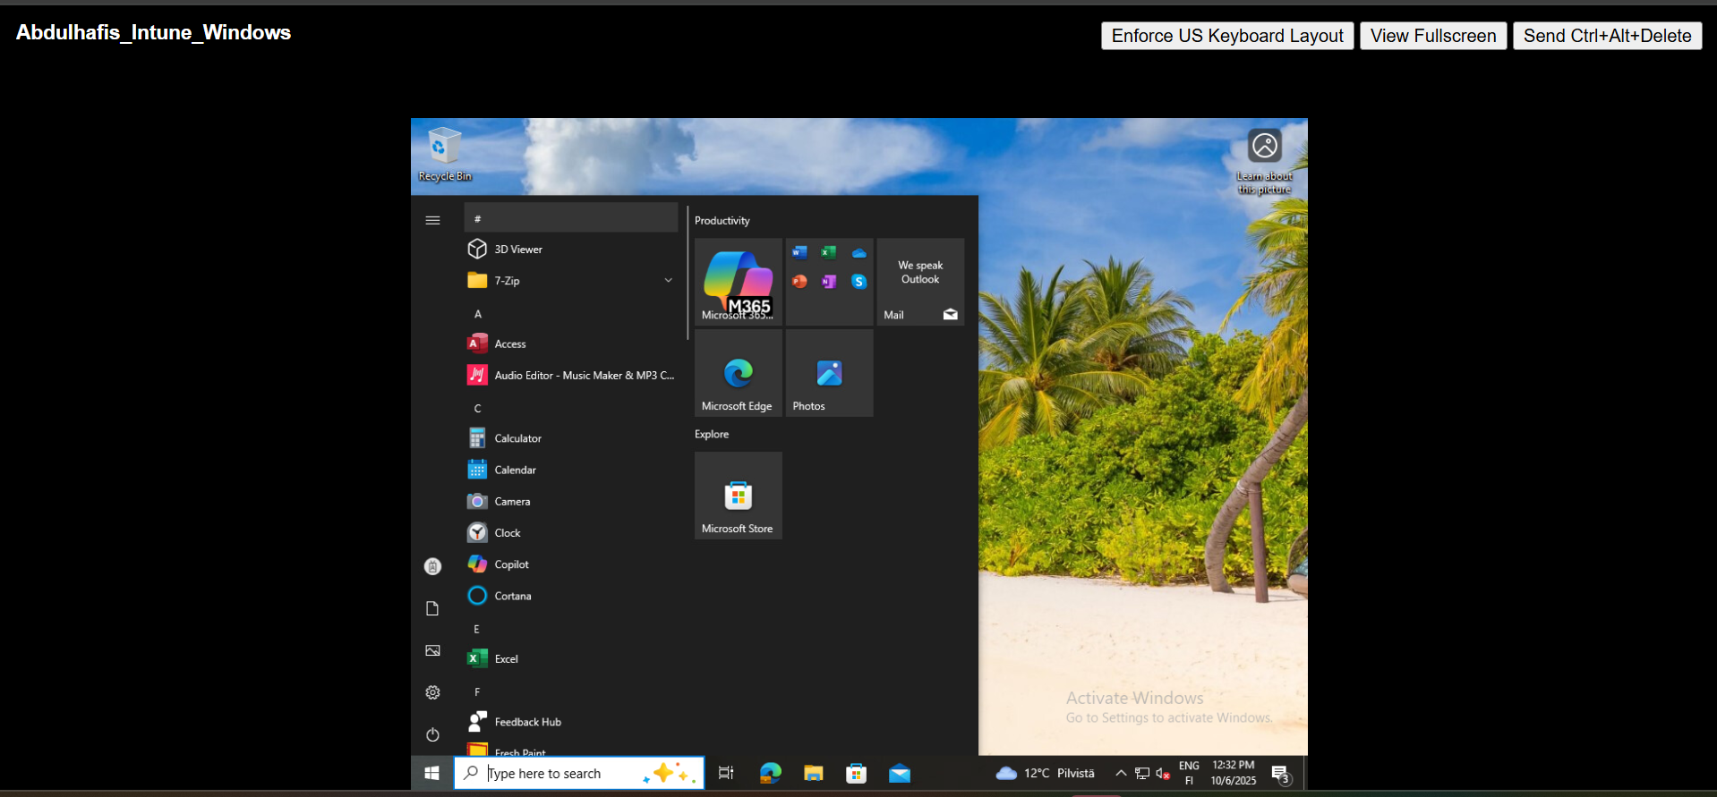

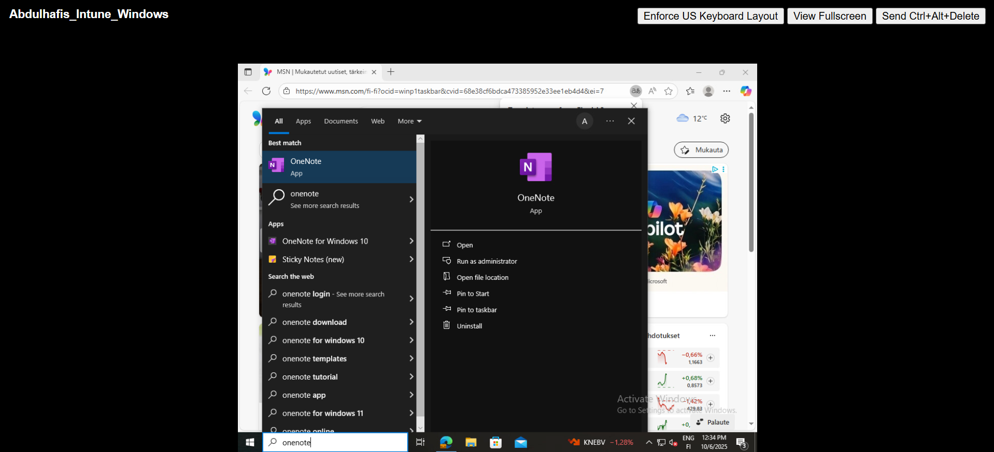

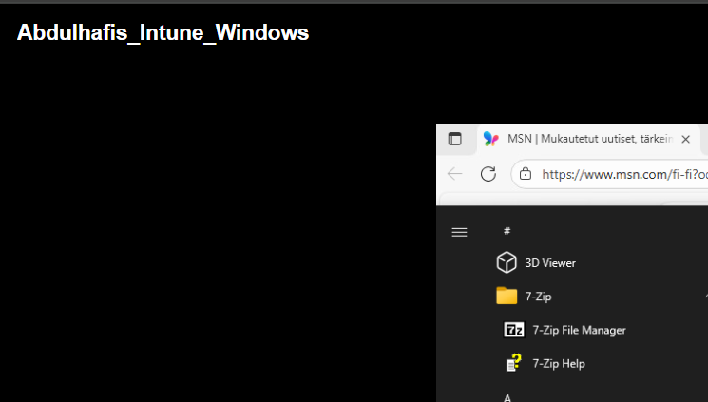

Edge browser start and home page

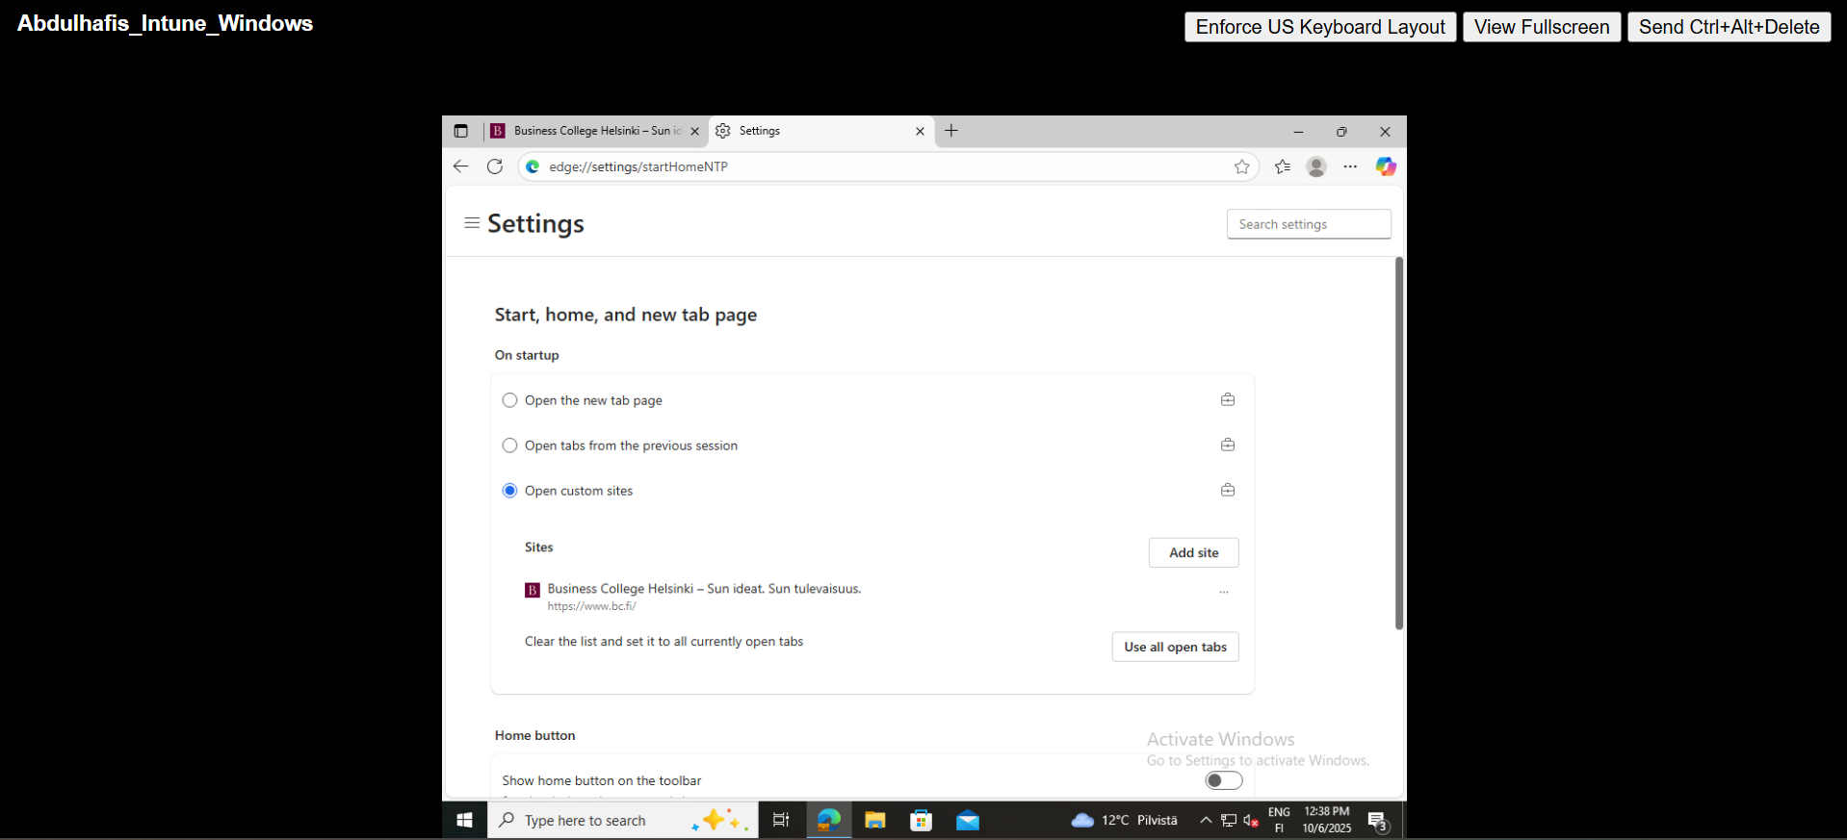

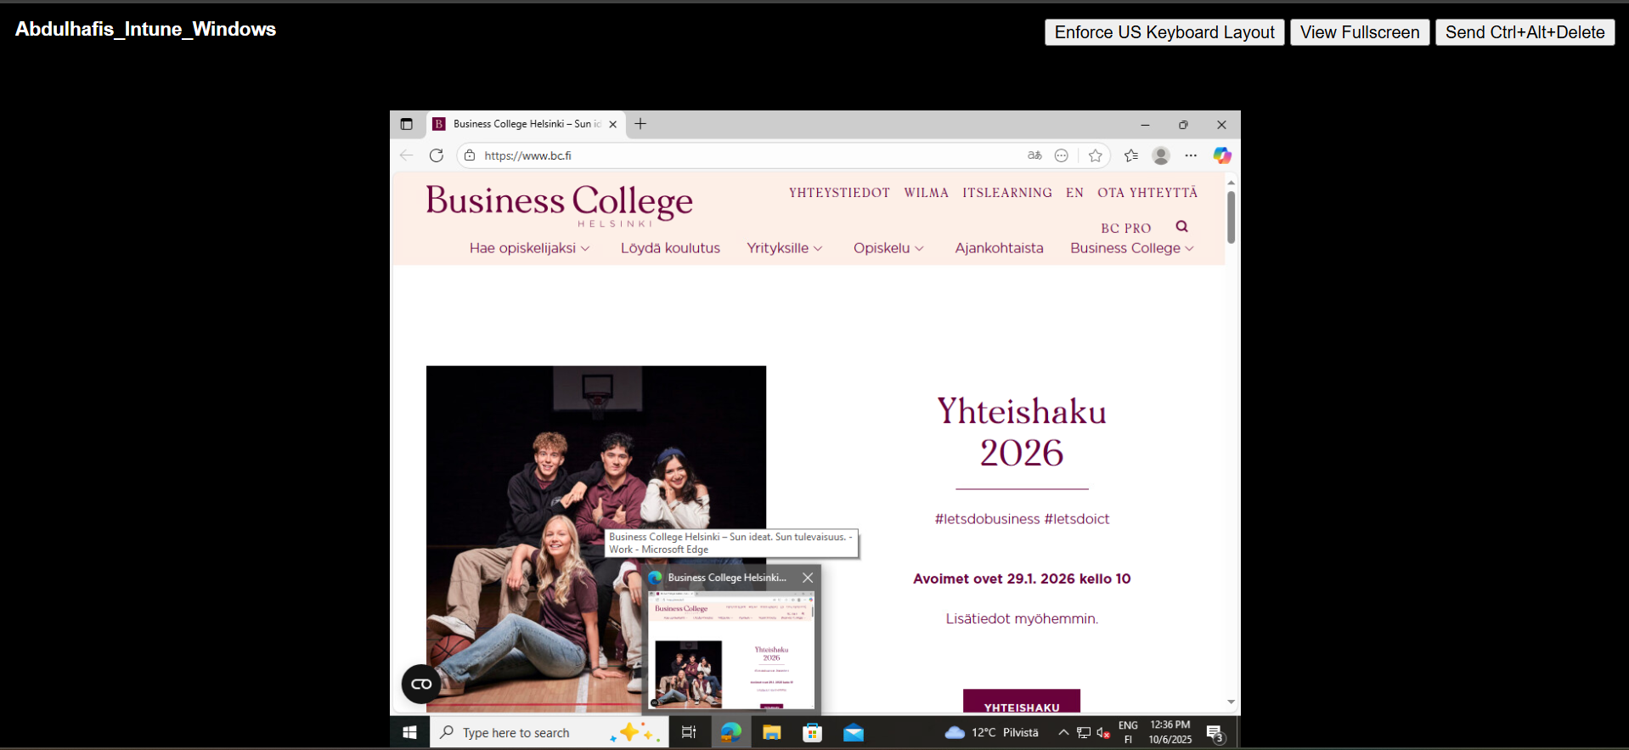

## Key Skills Demonstrated

* Endpoint management with Microsoft Intune
* Identity management using Microsoft Entra ID
* Automated device enrollment with Windows Autopilot
* Dynamic group-based assignments
* Application and policy deployment